**September 2026 - Best View Adventures: Big Bend NP**

**Fri. 9/18:** Arrive in Midland, TX; drive to Terlingua for night

**Sat. 9/19**: All-day rafting trip through Santa Elena Canyon

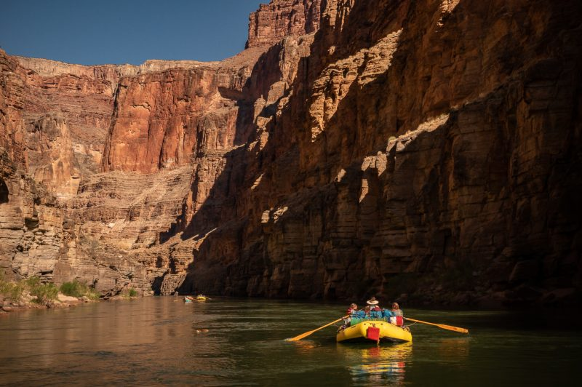

**Sun. 9/20**: Hiking in desert / Boquillas Canyon in Big Bend NP

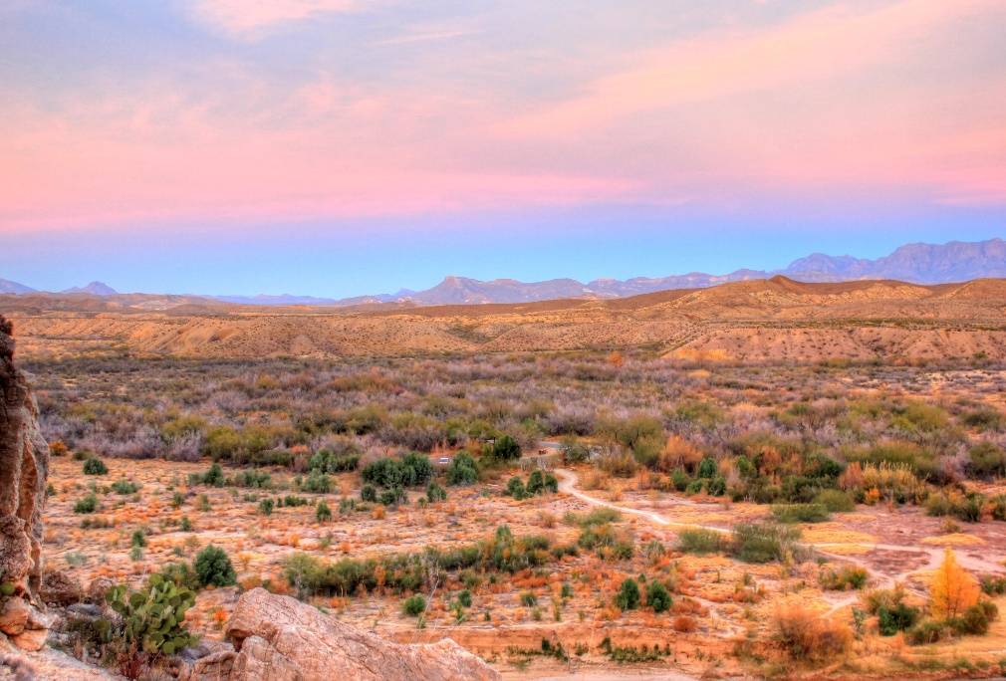

**Mon. 9/21**: Day hike up Emory Peak; night in Chisos Mt. Lodge

**Tues. 9/22**: Half-day hike in desert; afternoon drive to Midland; celebratory brewery dinner; night in Midland

**Wed. 9/23**: Flights home

**What’s Included:**

* Transportation throughout (from airport)
* Daily personal guide service
* Rafting trip; Park entrance fee
* Lodging for 5 nights
* Breakfasts and lunches (Sat - Tues)
* 2 dinners

Per Person cost: **$2495.00**