June 2027 - Best View Adventures – Moab, Utah

Thursday 6/17 – fly into Grand Junction, CO for afternoon meet-up; Fisher Towers hike; drive to Dead Horse Point State Park (Utah) for sunset; night in Moab
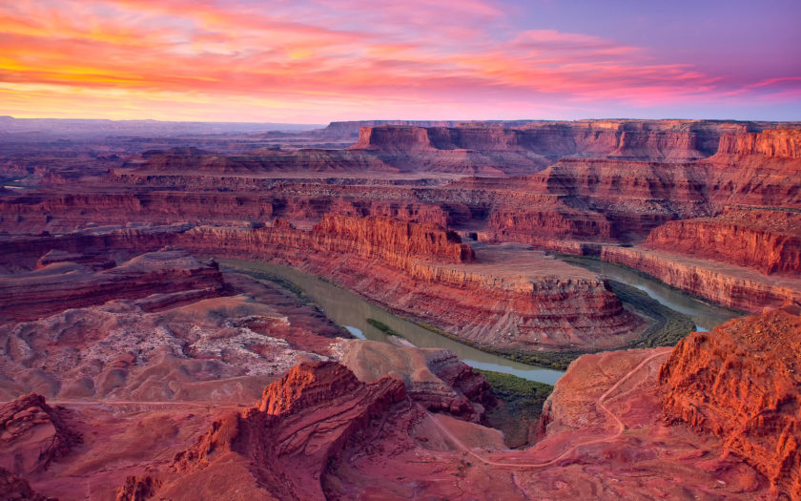

Friday 6/18 – day in Arches National Park - Devil’s Garden, Park Ave hike, explore Windows section; night in Moab
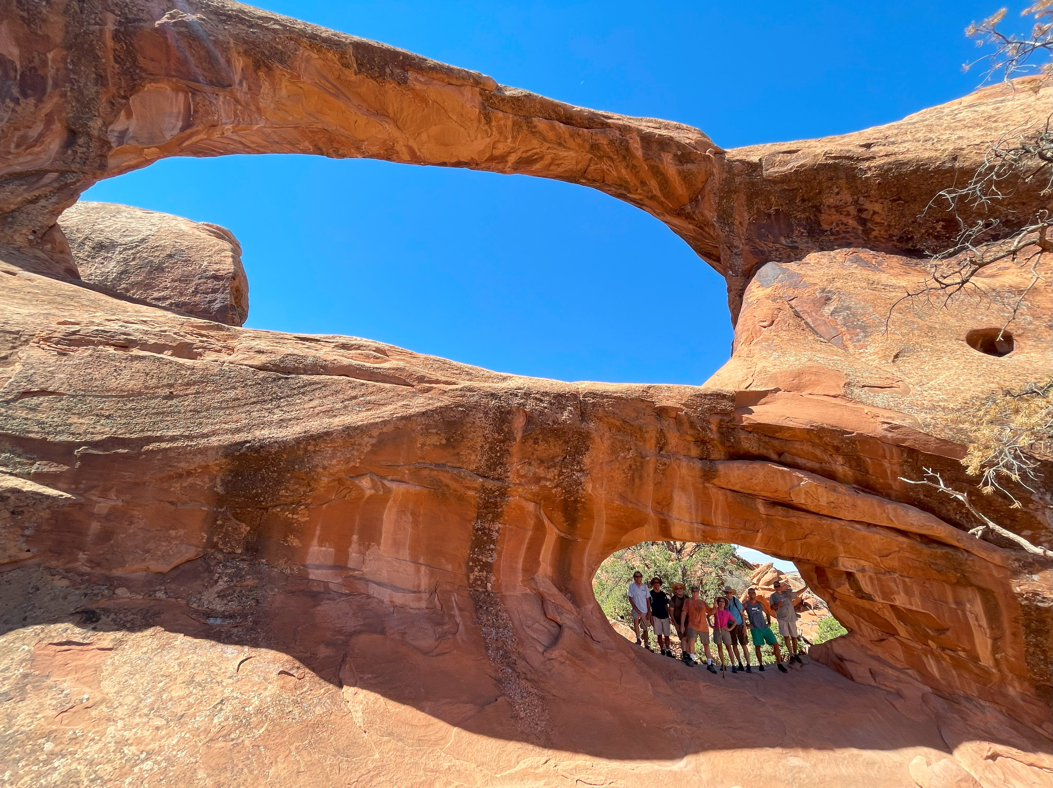

Saturday 6/19 – Morning in Canyonlands National Park; tour Island in the Sky section; afternoon hike to Delicate Arch in Arches NP; night in Moab
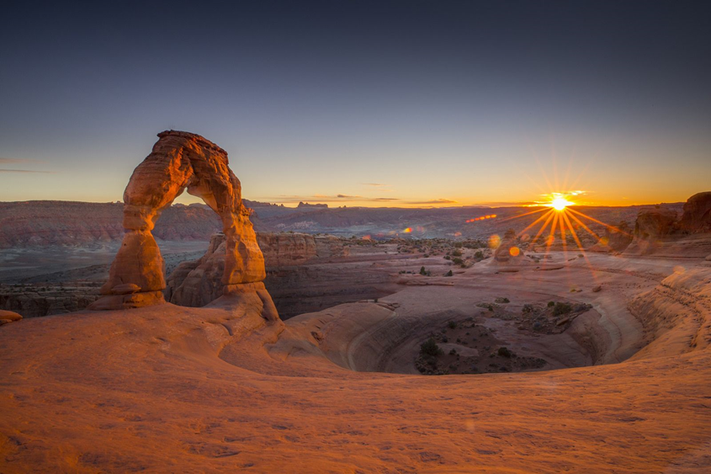

Sunday 6/20 – Clients’ choice of activity options:
Whitewater Rafting - https://www.moabadventurecenter.com/westwater-canyon-rafting
Rock Climbing - https://deserthighlights.com/tour/looking-glass-arch/
Mountain Biking - https://moabcyclery.com/day-tours/ (whatever level you choose)
Hiking – Needles district of Canyonlands National Park
Drive over to Green River, UT for the night.

Monday 6/21 – morning hike in Little Wild Horse Canyon; hike in Goblin Valley State Park ( https://duckduckgo.com/?q=images+of+goblin+valley+state+park&atb=v314-6&iax=images&ia=images ); Moonscape Overlook on way to Torrey for the night

Tuesday 6/22 – day in Capitol Reef National Park; hike to Cassidy Arch, Hickman Bridge, Cathedral Valley; back to Torrey for the night
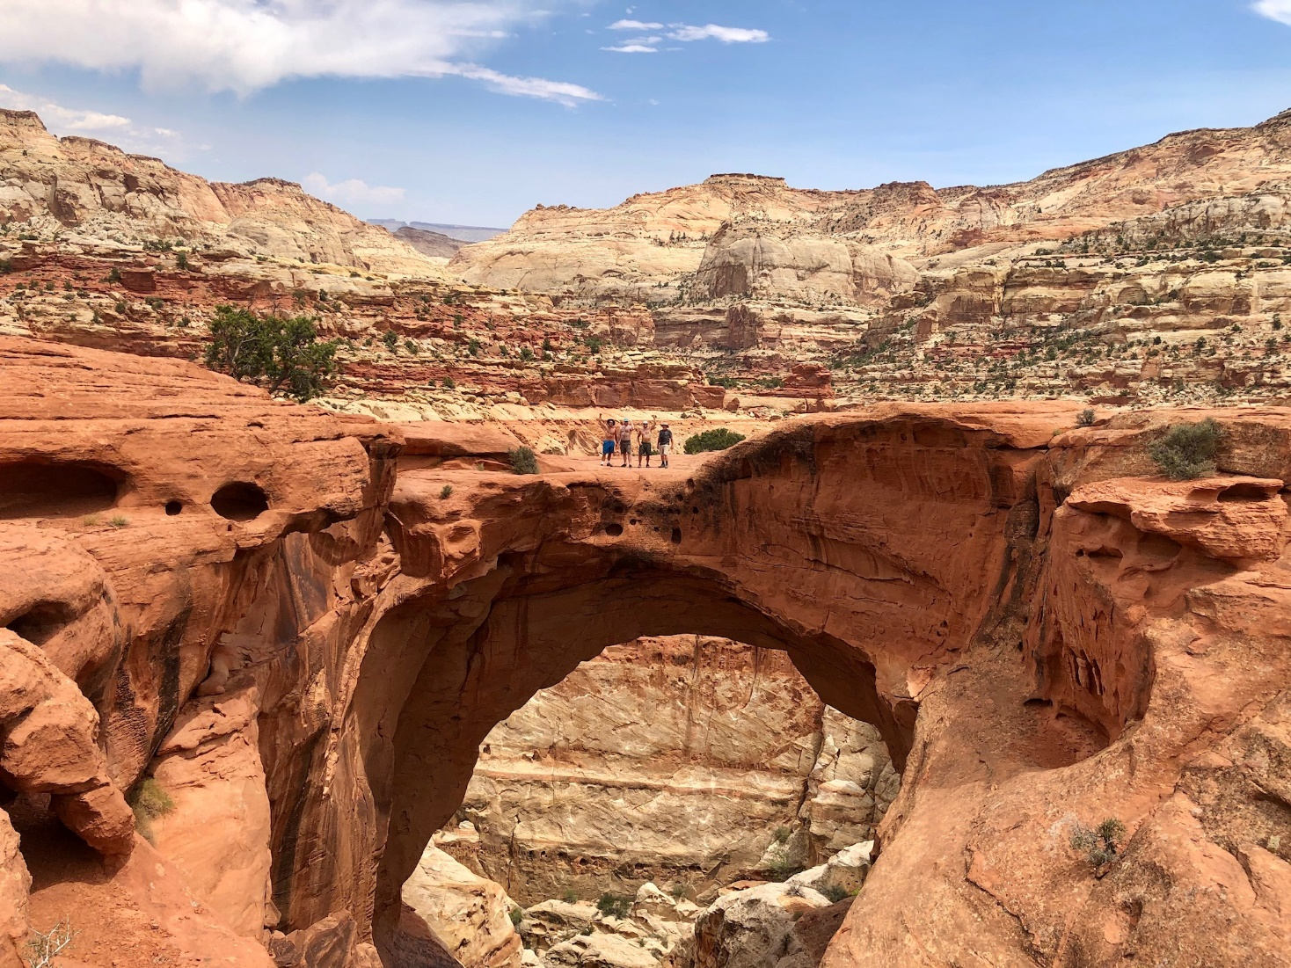
Wednesday 6/23 – Morning hike in Cottonwood Wash; afternoon tour of Colorado National Monument; Celebratory dinner at Rockslide Brewery in Grand Junction
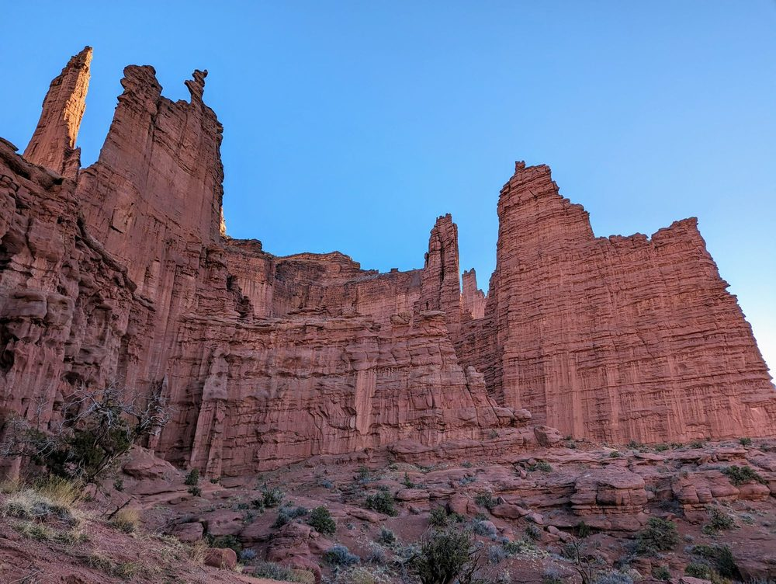
Thursday 6/24 – Flights home.
What’s included:

- Daily “Best View Adventures” guide service
- Lodging (double-occupancy), 7 nights
- Transportation throughout
- Entrance fees to 3 National Parks, 2 State Parks, and 1 National Monument
- “Client’s Choice” of Sunday activities
- Meals: 6 breakfasts, 6 lunches, 2 dinners
- Snacks and drinks aboard vehicles
Total Trip Cost = $2695 per person

(Pick-up and drop off spot = Grand Junction, CO airport)

