**BVA Trip – May 2026: Appalachian Mountains Parks**

**Fri. 5/15 –** Arrive in Washington D.C.; drive to Shenandoah NP; hike to Overall Run Falls; Skyline Drive to Big Meadows Lodge for night

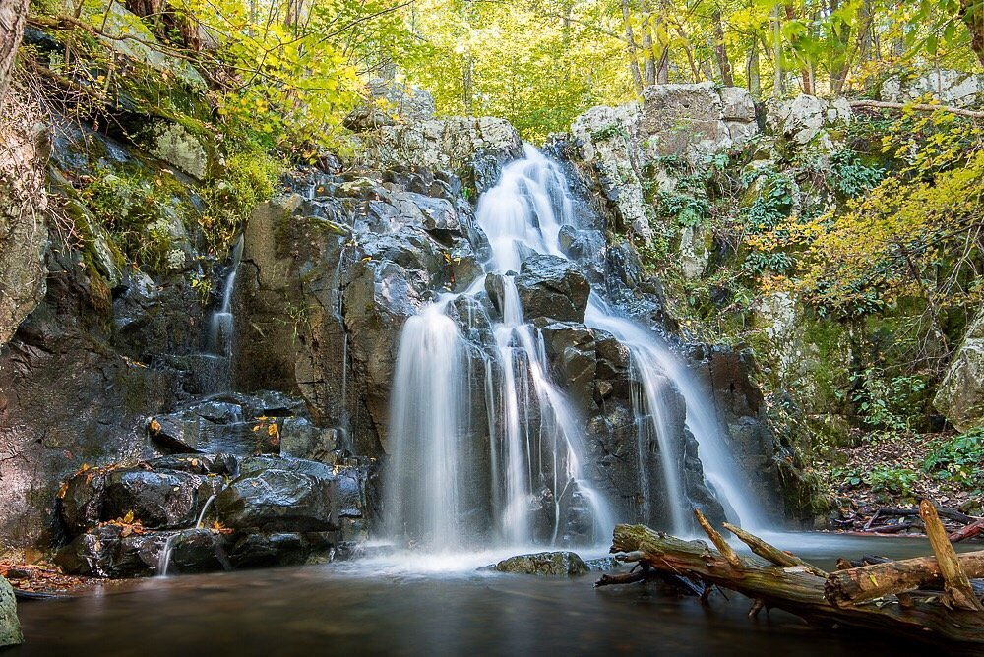

**Sat 5/16** – Morning hike to Rapidan Camp; Skyline Drive to Rockfish Gap; hike section of AT; drive to Lewisburg, WV for night

Su**n. 5/17 –** New River Gorge NP; options to hike or ½-day climb/rappel at Bridge Buttress; Colonial Heights, TN for night

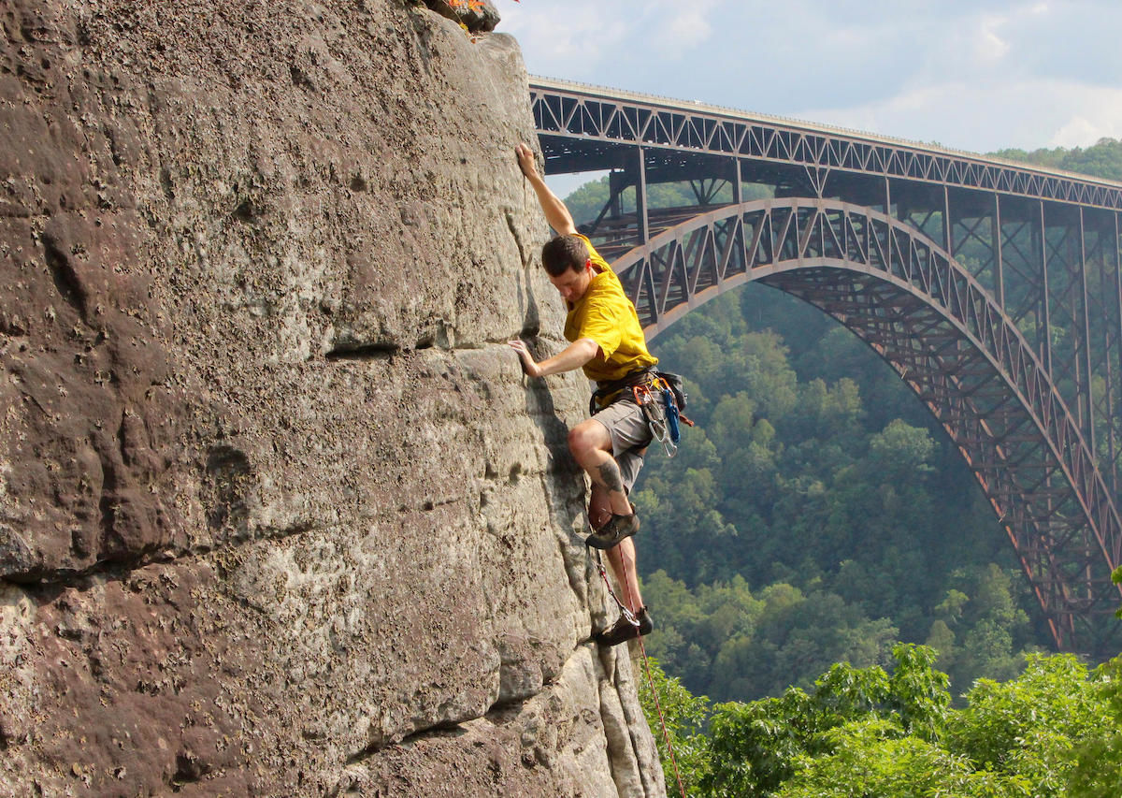

**Mon. 5/18** – Great Smokey Mts NP; Newfound Gap Road to hike Andrews Bald; Gatlinburg for night

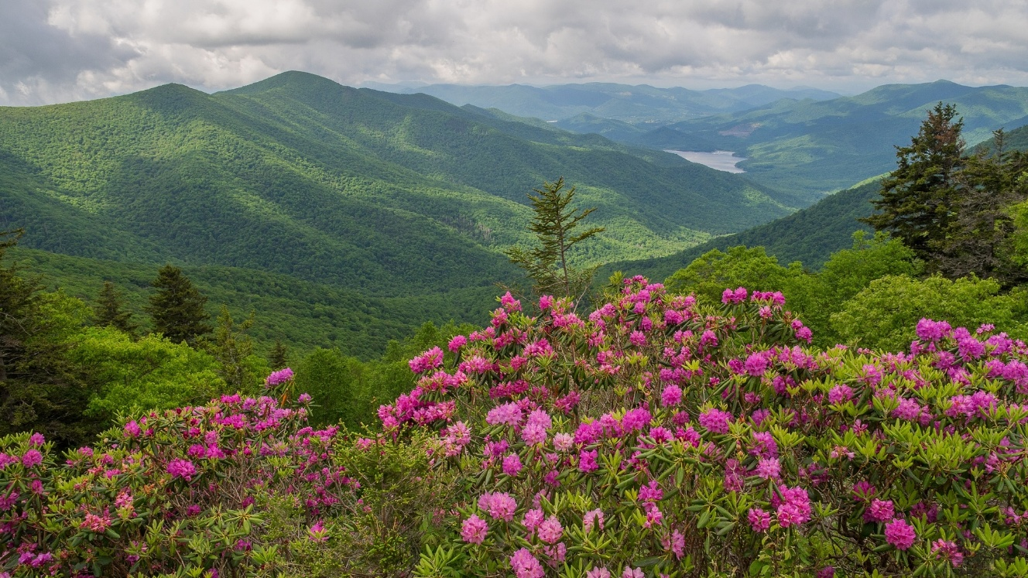

**Tues. 5/19** – Hikes in GSM NP; Grotto Falls; firefly viewing at night (if an option); night in Gatlinburg

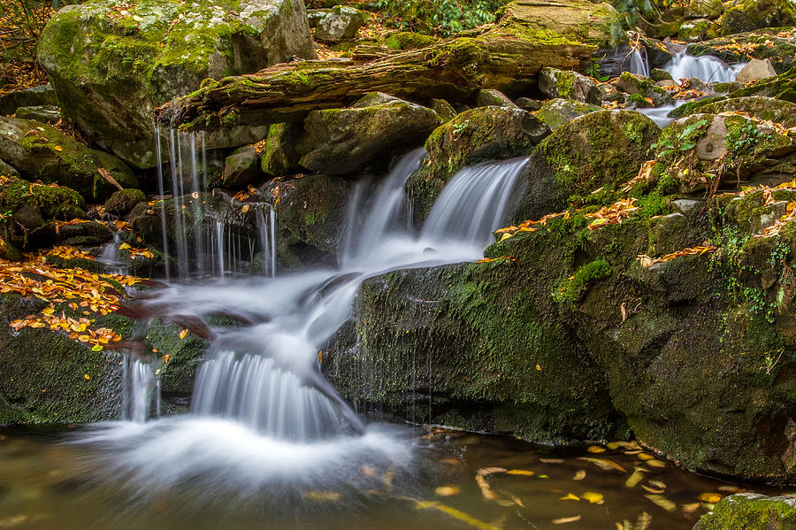

**Wed. 5/20** – Clingman’s Dome (now named “Kuwohi”); Ashville for the night

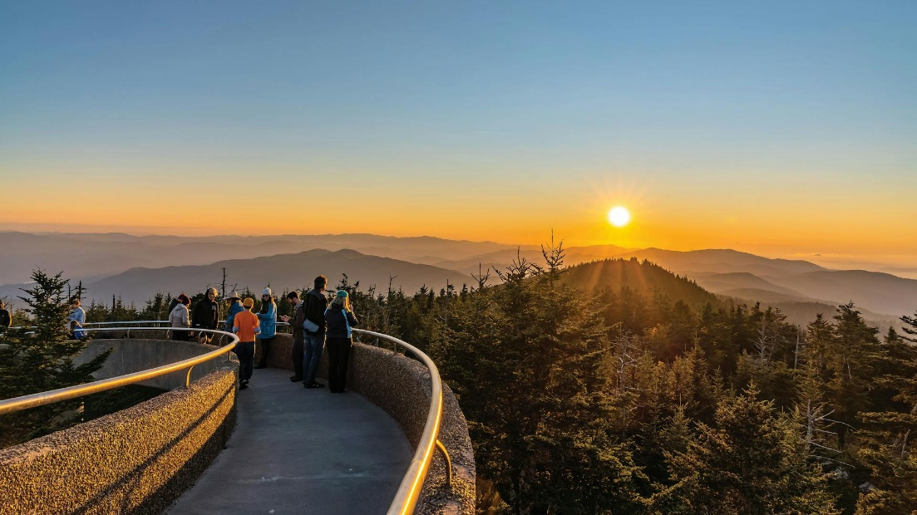

**Thurs. 5/21** – Fly home from Ashville

**What is Included:**

* Transportation throughout
* Park entrance fees
* Lodging for 6 nights
* Activities (climbing/rappelling)
* Breakfasts and lunches for 5 days, 2 dinners
* Snacks, soft drinks, gorp, power bars, etc. in vans

**Cost**: (to be determined)