August 2026 - Best View Adventures: Alaska

Fri. 8/21 – Travel day; arrive in Anchorage; ( https://www.adn.com/alaska-visitors-guide/2021/06/28/your-guide-to-an-epic-seward-highway-road-trip/ ); drive to Seward for night
Sat. 8/22 – All-day sight-seeing cruise into Kenai Fjords NP; night in Seward
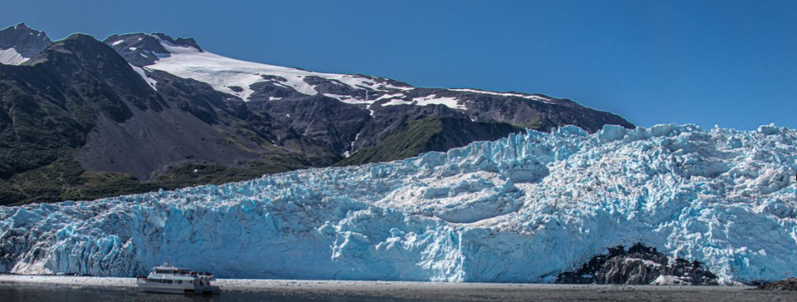
Sun. 8/23 – Hike to Exit Glacier in Kenai Fjords NP; drive to Anchorage for night
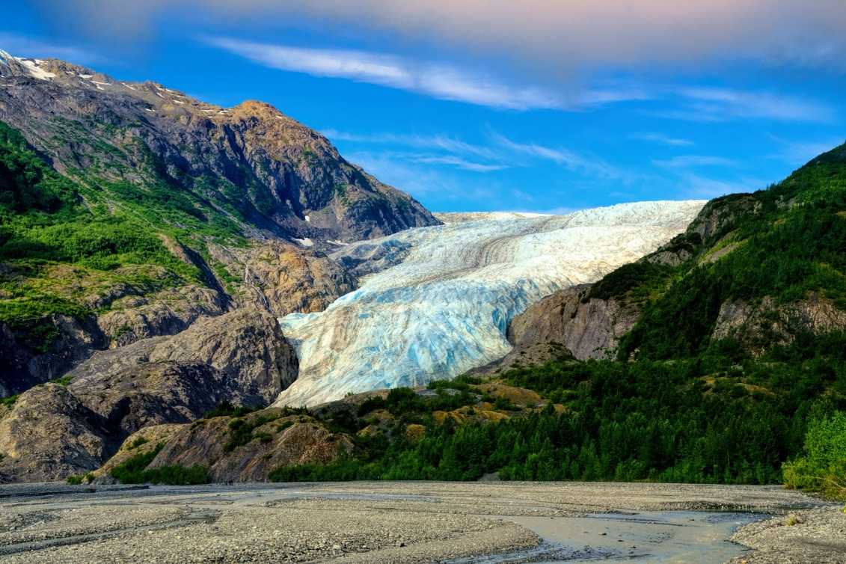
Mon. 8/24 – Day of options in Anchorage:
- Hike up Flattop Mountain ( https://www.anchorage.net/outdoors/the-chugach-mountains/flattop-mountain/ )
- Bear-viewing flight to Lake Clark National Park (https://flyakair.com/bear-flightseeing-alaska/ – additional cost )
- Explore local attractions : https://akwildberry.com/about-us/worlds-largest-chocolate-falls/ ; https://www.qiviut.com/ ; https://theulufactory.com/ ; etc.

Tues. 8/25 – Drive the George Parks National Scenic Highway up to Denali; stops include the Iditarod Hall of Fame and afternoon in Talkeetna (https://www.talkeetnachamber.org/ ). Flightseeing trips around Denali may be an additional option (https://www.flyk2.com/ ); night at Denali Cabins.
Wed. 8/26 – All-day bus tour deep into Denali National Park, with interpretive ranger ( https://www.cruisecritic.com/articles/denali-tundra-wilderness-bus-tour-excursion-review ). Night at Denali Cabins.
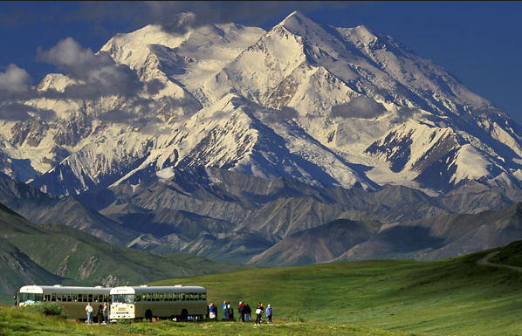
Thurs. 8/27 – Drive over Hatcher Pass to Independence Mine State Park (https://www.alaska.org/detail/independence-mine-historical-state-park ); stop at a Musk Ox farm ( https://www.muskoxfarm.org/ ); night in Eagle River

Fri. 8/28 – Travel day, flights home

Trip Details
Included:
- Transportation throughout (from Anchorage airport)
- Daily personal guide service
- All park entrance fees
- Lodging for 7 nights
- Breakfasts and lunches (Sunday – Friday)
- 2 dinners
- Activities: Kenai Fjords National Park boat tour
Denali National Park bus tour
Musk Ox farm tour

Per Person cost: $3195.00

