June 2027 - Best View Adventures – Northern Waters trip

Wednesday, June 2 – fly into Duluth, MN for meet-up; visit to Hockey Hall of Fame on drive up to Kabetogama visitor center in Voyageurs National Park; The Pines of Kabetogama ( https://thepineskab.com/mn-cabin-rentals/family-resort-mn/ ) for the night
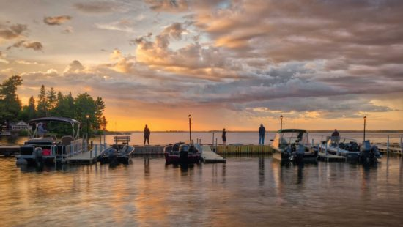

Thursday, June 3 – boat shuttle to Locator Lake Trail, hike to cached canoes for day of paddling and/or fishing in various lakes; back to Paul Bunyan cabin
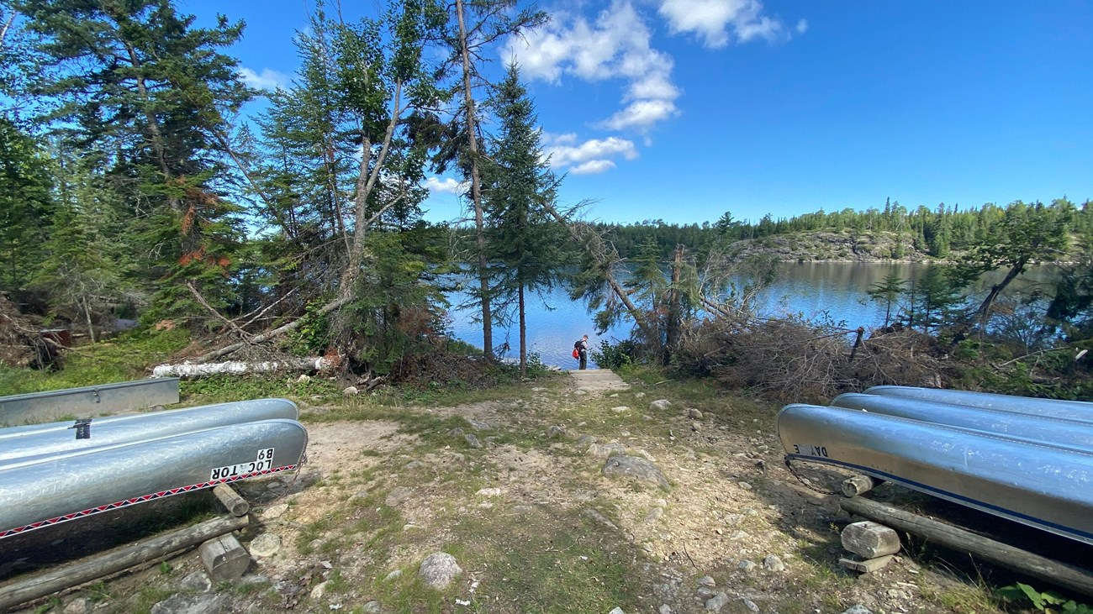

Friday, June 4 – Day trip to Rainy Lake visitor center in Voyageurs NP; Ranger tour in a 26-foot voyageur north canoe; stop in International Falls on way back to cabin
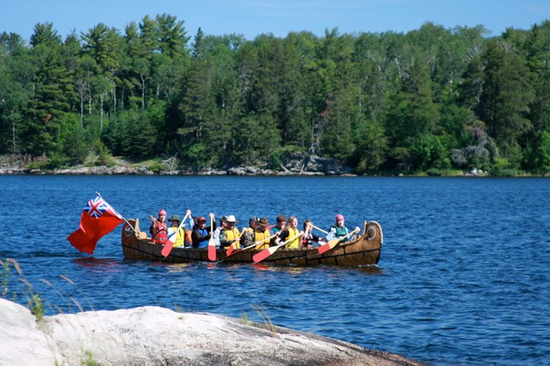

Saturday, June 5 – Ash River visitor center in Voyageurs NP; hikes to overlooks; drive to Grand Portage for the night
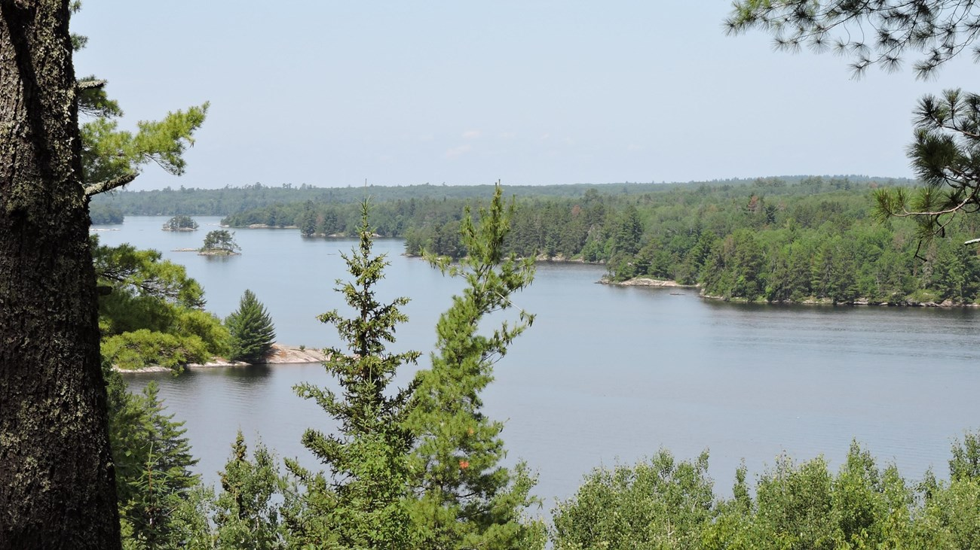

Sunday, June 6 – Ferry to Isle Royale National Park; afternoon hike; Rock Harbor Lodge for the night
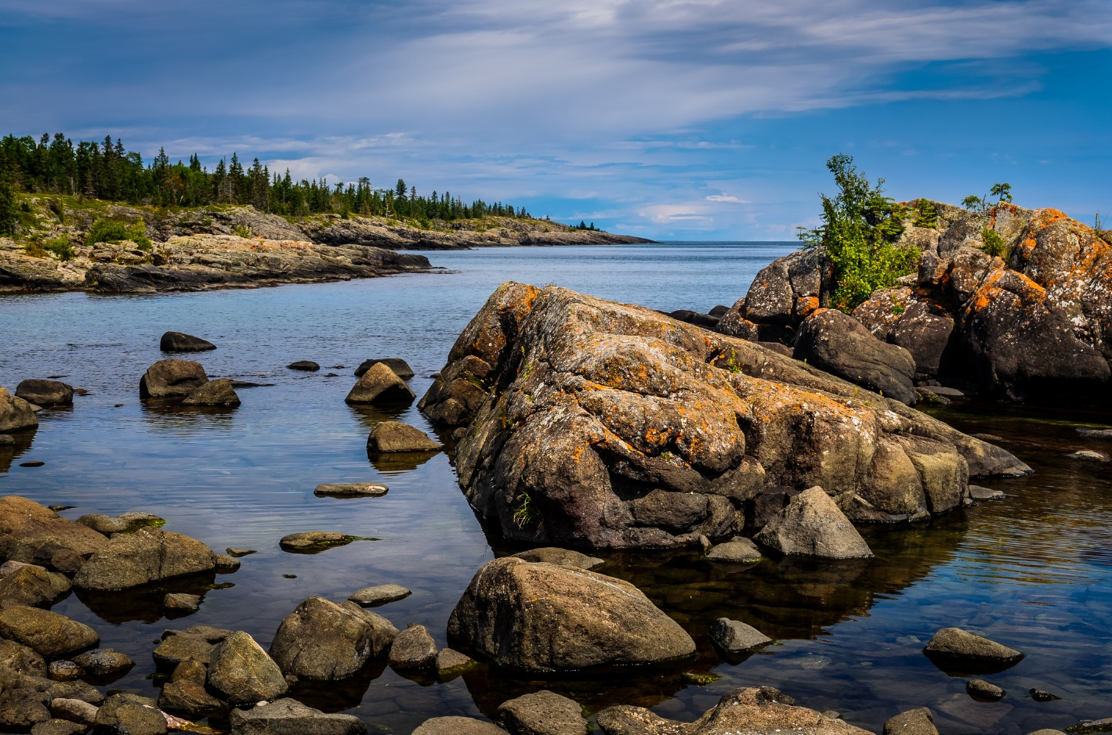

Monday, June 7 – canoes or kayaks in morning; afternoon hike; Lodge for the night
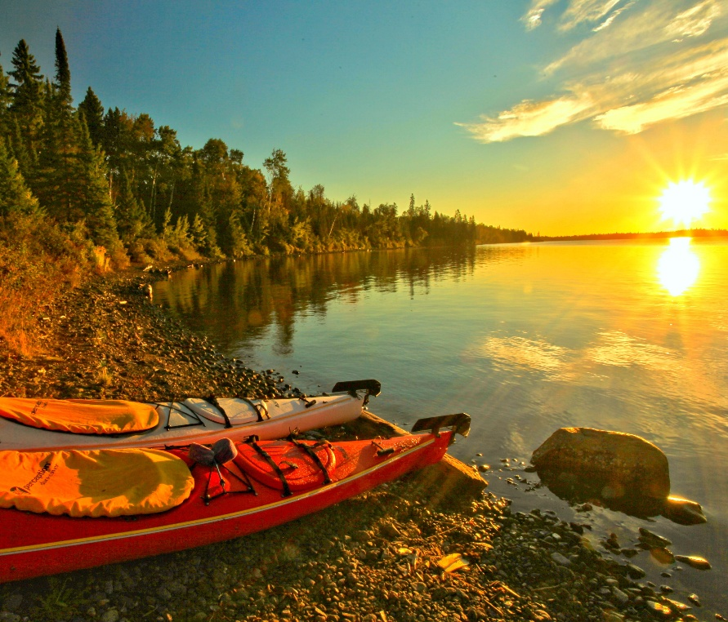

Tuesday, June 8 – Ferry back to Grand Portage; visit to Grand Portage National Monument; drive shore of Lake Superior to Duluth; wind-up dinner
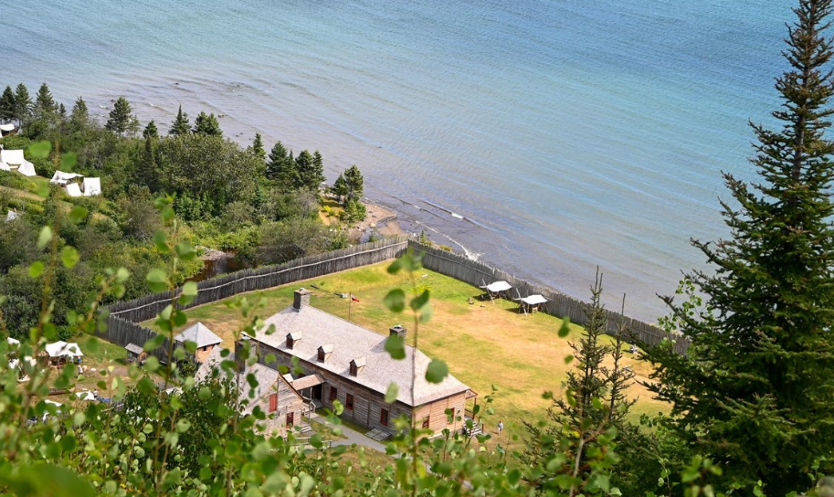
Wednesday, June 9 – Flights home
What’s included:
- Daily “Best View Adventures” guide service
- Lodging (double-occupancy), 7 nights
- Transportation throughout
- Entrance fees to 2 National Parks
- Meals: 6 breakfasts, 6 lunches, 1 dinner
- Snacks and drinks aboard vehicles

Total Trip Cost = $3295 per person
(Pick-up and drop off spot = Duluth, MN)

