**August 2026 - Best View Adventures: Alaska**

**Sat. 8/22** – Travel day; arrive in Anchorage; ( <https://www.adn.com/alaska-visitors-guide/2021/06/28/your-guide-to-an-epic-seward-highway-road-trip/> ); drive to Seward for night

**Sun. 8/23** – All-day sight-seeing cruise into **Kenai Fjords NP**; night in Seward

**Mon. 8/24** – Hike to Exit Glacier in Kenai Fjords NP; drive to Anchorage for night

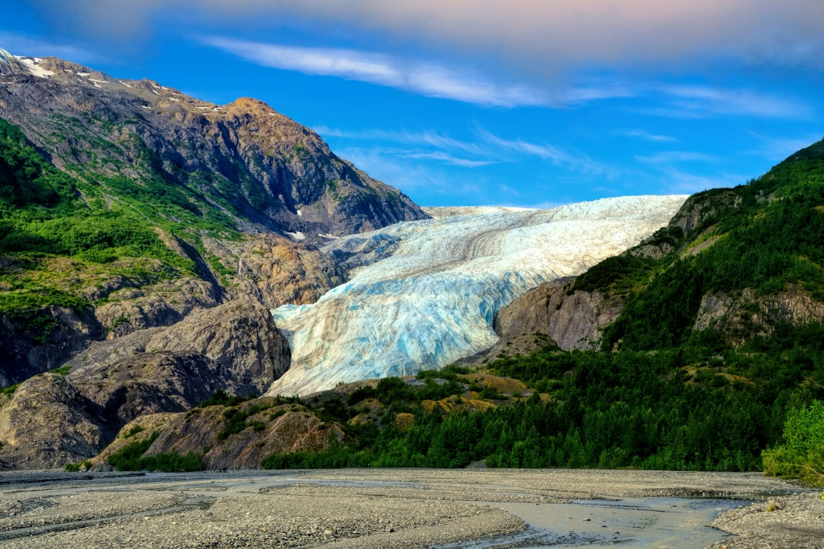

**Tues. 8/25** – Day of options in Anchorage:

* Hike up Flattop Mountain ( <https://www.anchorage.net/outdoors/the-chugach-mountains/flattop-mountain/> )
* Bear-viewing flight to Lake Clark National Park (<https://flyakair.com/bear-flightseeing-alaska/> – additional cost )
* Explore local attractions : <https://akwildberry.com/about-us/worlds-largest-chocolate-falls/> ; <https://www.qiviut.com/> ; <https://theulufactory.com/> ; etc.

**Wed. 8/26** – Drive the George Parks National Scenic Highway up to Denali; stops include the Iditarod Hall of Fame and afternoon in Talkeetna (<https://www.talkeetnachamber.org/> ). Flightseeing trips around Denali may be an additional option (<https://www.flyk2.com/> ); night in Denali Park.

**Thurs. 8/27** – All-day bus tour deep into **Denali National Park**, with interpretive ranger ( <https://www.cruisecritic.com/articles/denali-tundra-wilderness-bus-tour-excursion-review> ). Night at Denali Park.

**Fri. 8/28** – Drive over Hatcher Pass to Independence Mine State Park (<https://www.alaska.org/detail/independence-mine-historical-state-park> ); stop at a Musk Ox farm ( <https://www.muskoxfarm.org/> ); wind-up dinner at 49th State Brewery ( <https://www.49thstatebrewing.com/anchorage/> ); night in Anchorage

**Sat. 8/29** – Travel day, flights home

**Trip Details**

Included:

* Transportation throughout (from Anchorage airport)
* Daily personal guide service
* All park entrance fees
* Lodging for 7 nights
* Breakfasts and lunches (Sunday – Friday)
* 2 dinners
* Activities: Kenai Fjords National Park boat tour

Denali National Park bus tour

Musk Ox farm tour

Per Person cost: **$3195.00**