**April 2025 Best View Adventure trip :**

**New Mexico / Texas**

Wed. 4/09 : meet at El Paso airport; drive to Alamogordo, NM

Thurs. 4/10 : hikes in **White Sands NP**; side trip to Roswell; drive to Carlsbad for the night

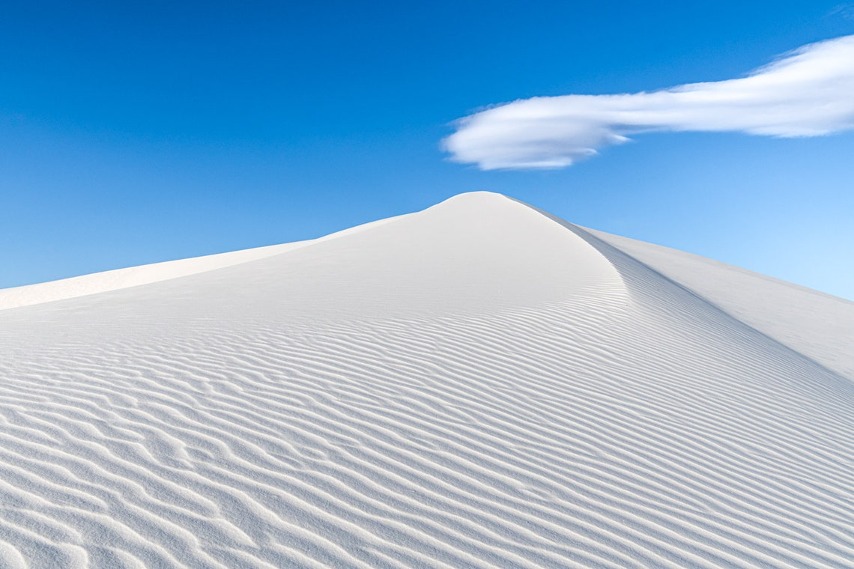

Fri. 4/11 – **Carlsbad Caverns NP** ; General tour in morning ; Ranger-led tour in afternoon ; bat-flight at night ; Carlsbad for night

Sat. 4/12 : Guadalupe Mts NP – hike up Guadalupe Peak ; drive to El Paso

Sun. 4/13 : flights home

**Trip Details**

**What is included**:

* Transportation throughout
* Personal Guided hikes
* Park entrance fees
* Lodging for 4 nights
* Breakfasts and lunches all 4 days, 1 dinner
* Snacks, soft drinks, gorp, power bars, etc. in vans

**Total Cost** : $1495 per person (limit of 6 clients)