Sierra Nevada Adventure Tour

John Muir referred to them as his precious “Range of Light” – the staggeringly beautiful mountains that divide California’s central valley from the Great Basin of Nevada. Hiking and climbing to vantage points that will leave you standing in awe of vast panoramas of mystifying size and scale, this week-long exploration of the three wonderous National Parks in the Sierra Nevadas is guaranteed to impart lifelong memories!

- Sequoia NP – spanning an elevation gain of 13,500’ from the Ash Mt entrance to the summit of Mt. Whitney, Sequoia offers one of the greatest displays of biodiversity found anywhere in the US. Our acclimatization day will consist of moderate hikes to experience the grandeur of the largest trees on earth and bring us atop a bald granite dome for a spectacular sunset vista (at 7200’).
- Kings Canyon NP – the less-frequented sister park is home to one of the deepest canyons in the US. We will warm up with a couple of easy morning hikes to amazing panoramas before tackling a more challenging half-day hike up to the largest waterfall in the park.
- Yosemite NP – it normally takes some serious work to get to the “Best Views”, but this park is arguably an exception. Throughout our four days in Yosemite, you will have options of strenuous, full-day hikes to incredible summits, casual strolls to the bases of thundering waterfalls, or moderately-taxing scrambles up granite domes. Whatever your choices, you may not have enough wall space back home to display your memorable images.

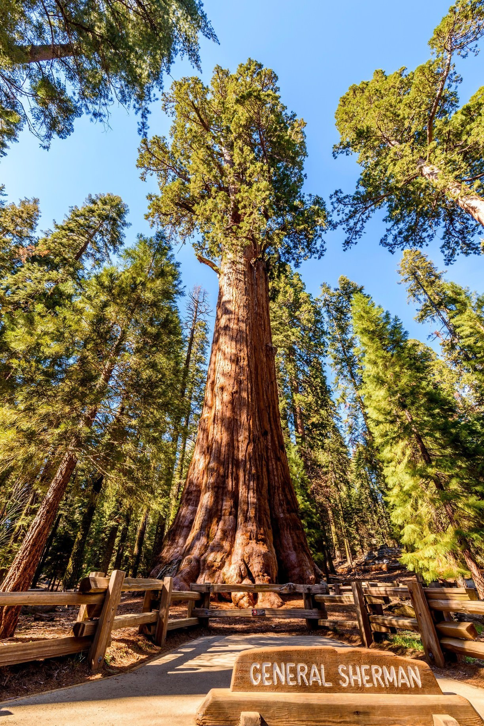
Sequoia National Park
(just for scale, the lower branches of General Sherman
are larger than any tree east of the Mississippi!)

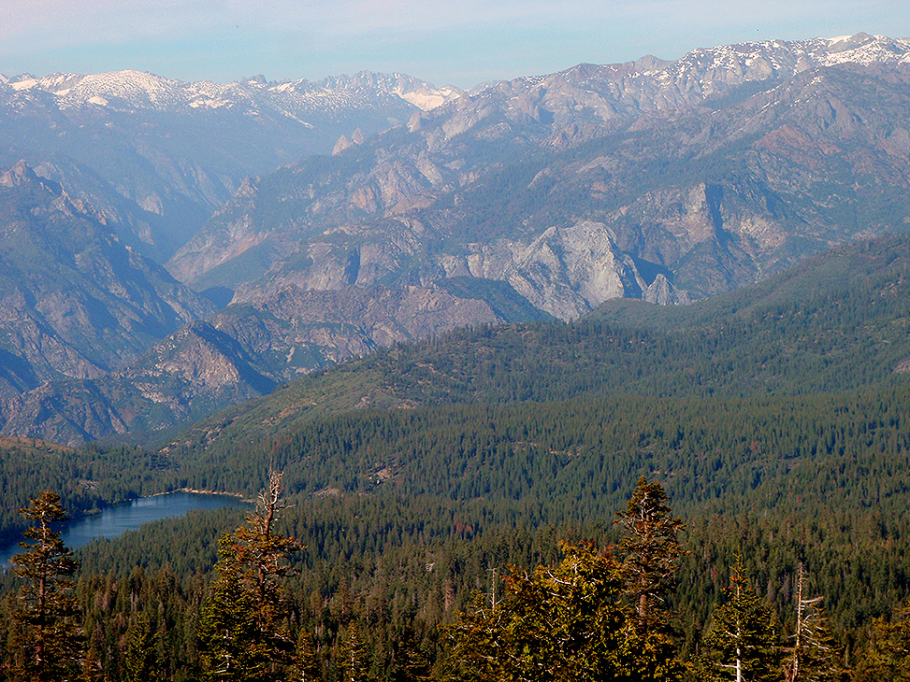
Hume Lake from Panoramic Point, Kings Canyon NP

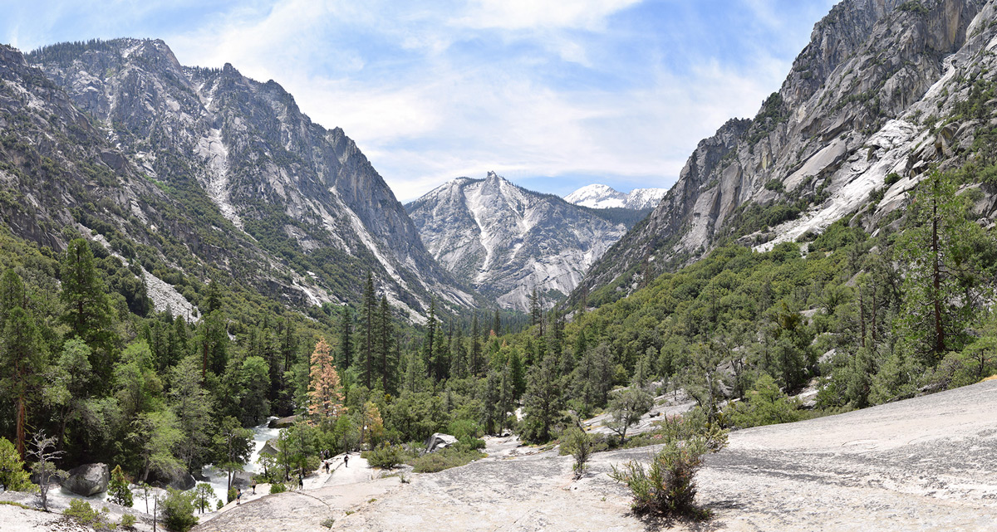
Mist Falls Trail, Kings Canyon National Park

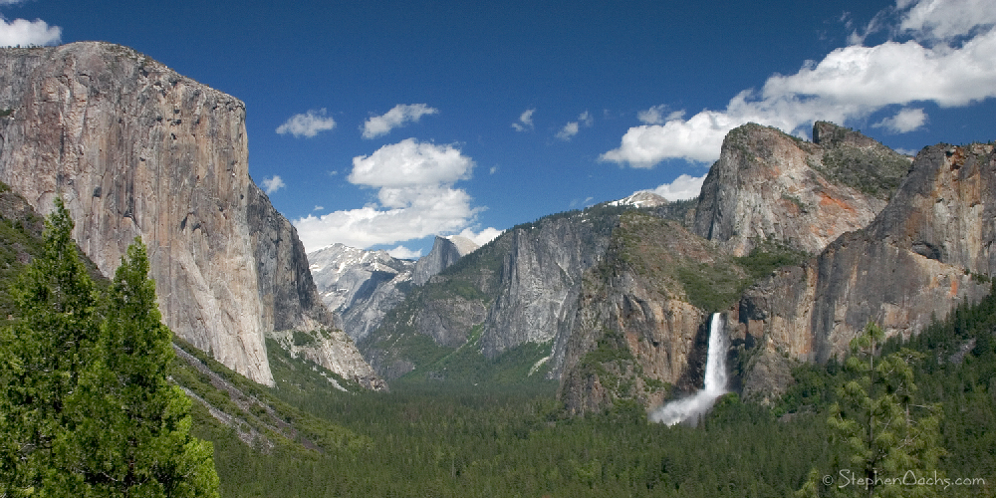
Yosemite Valley
Half Dome, from North Dome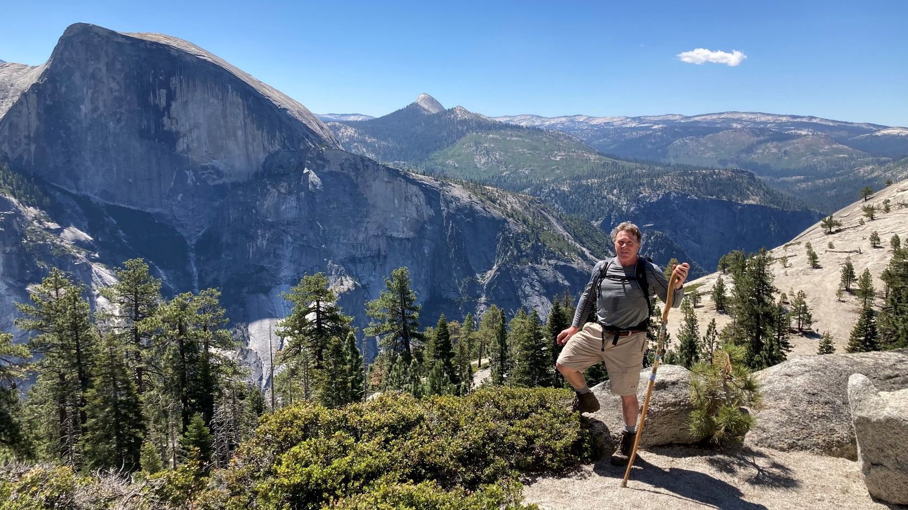

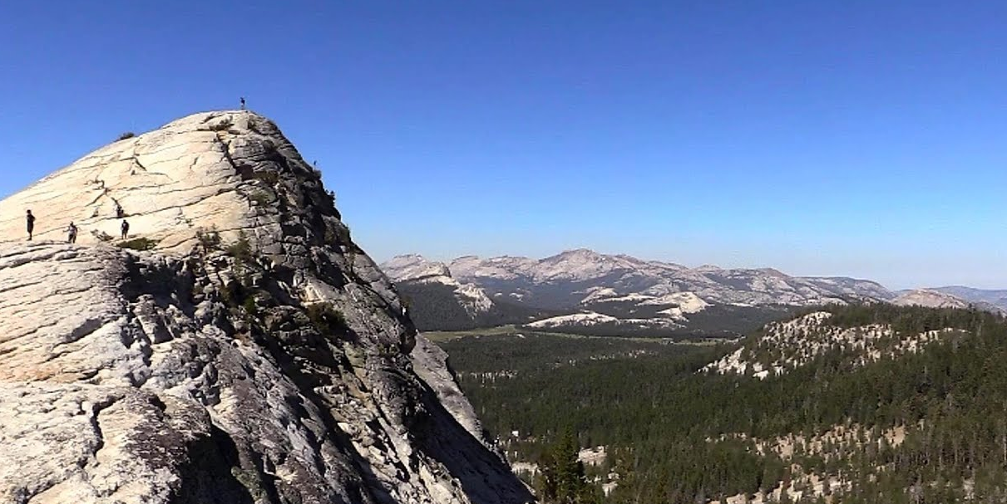
Lembert Dome, Tuolumne Meadows

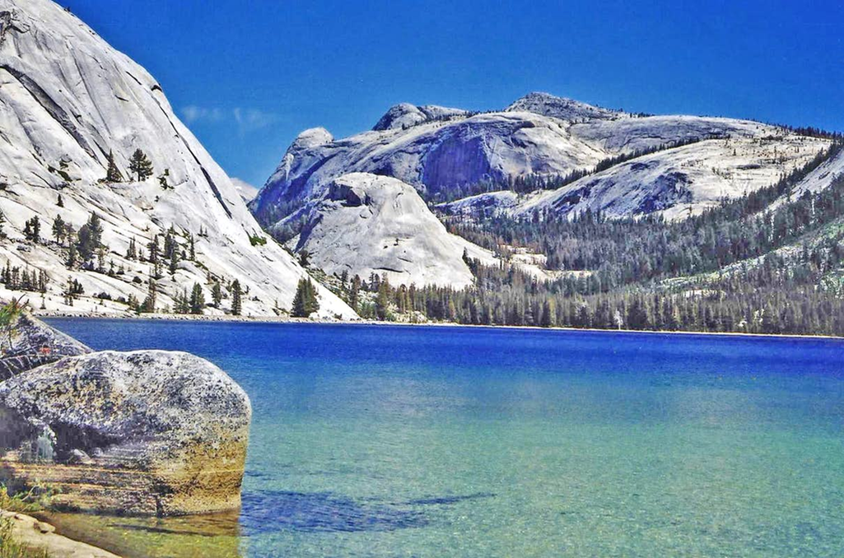

2025 Trip Details

Dates: meet at San Jose, CA airport Saturday afternoon, July 12th
Sunday, 7/13 = Sequoia National Park
Monday, 7/14 = Kings Canyon National Park
Tuesday – Friday, 7/15-7/18 = Yosemite National Park
Saturday, 7/19 = return home from San Jose, CA

What is included:
- Ground transportation throughout
- Personal Guide service on hikes
- Park entrance fees
- Lodging (Best Western hotels, John Muir Lodge in
Kings Canyon and private home in Yosemite)
- 7 Breakfasts, 6 lunches, 4 Dinners
- Snacks, soft drinks, gorp, power bars, etc.

Total Cost : $2695 per person (limit of 8 clients)

