April 2027 - Best View Adventures – Four Corners trip

Thursday 4/21 – fly into Albuquerque, NM for meet-up; afternoon in Petroglyphs Nat’l Monument; drive to Gallup, NM for the night
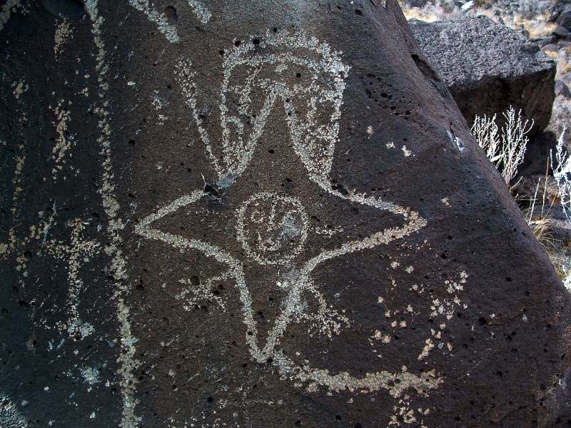

Friday, 4/23 – day of hikes in Petrified Forest NP and Painted Desert; drive to Farmington, NM
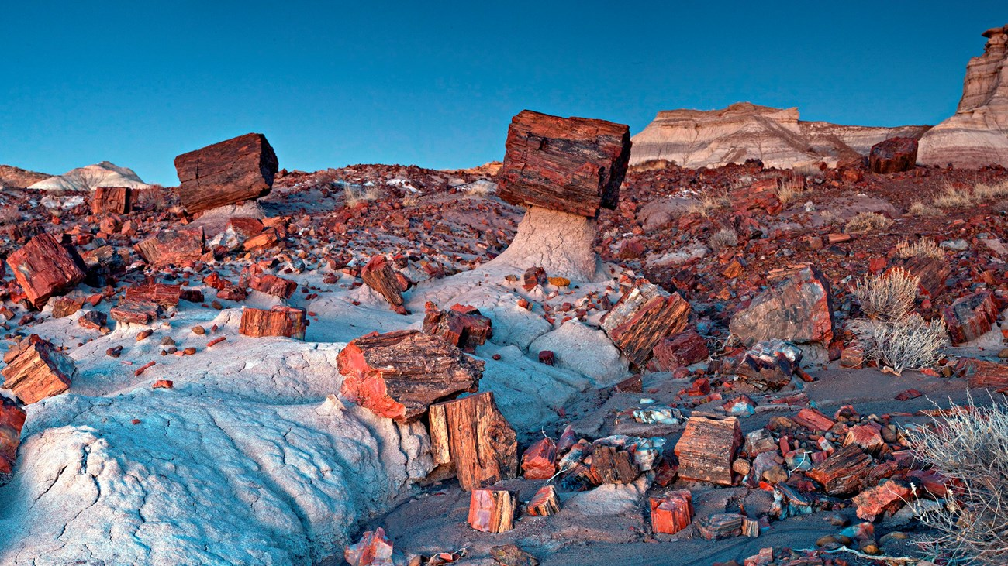

Saturday, 4/24 – All day in Mesa Verde NP; ranger tours; night in Cortez, CO
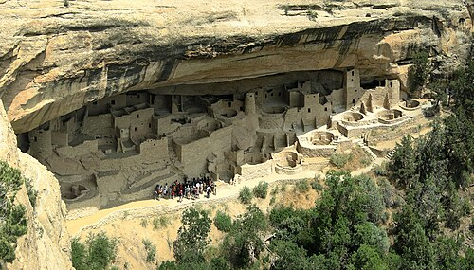

Sunday, 4/25 – day of exploring Hovenweep NM; Canyons of the Ancients NM, and hike to base of Shiprock; night in Farmington
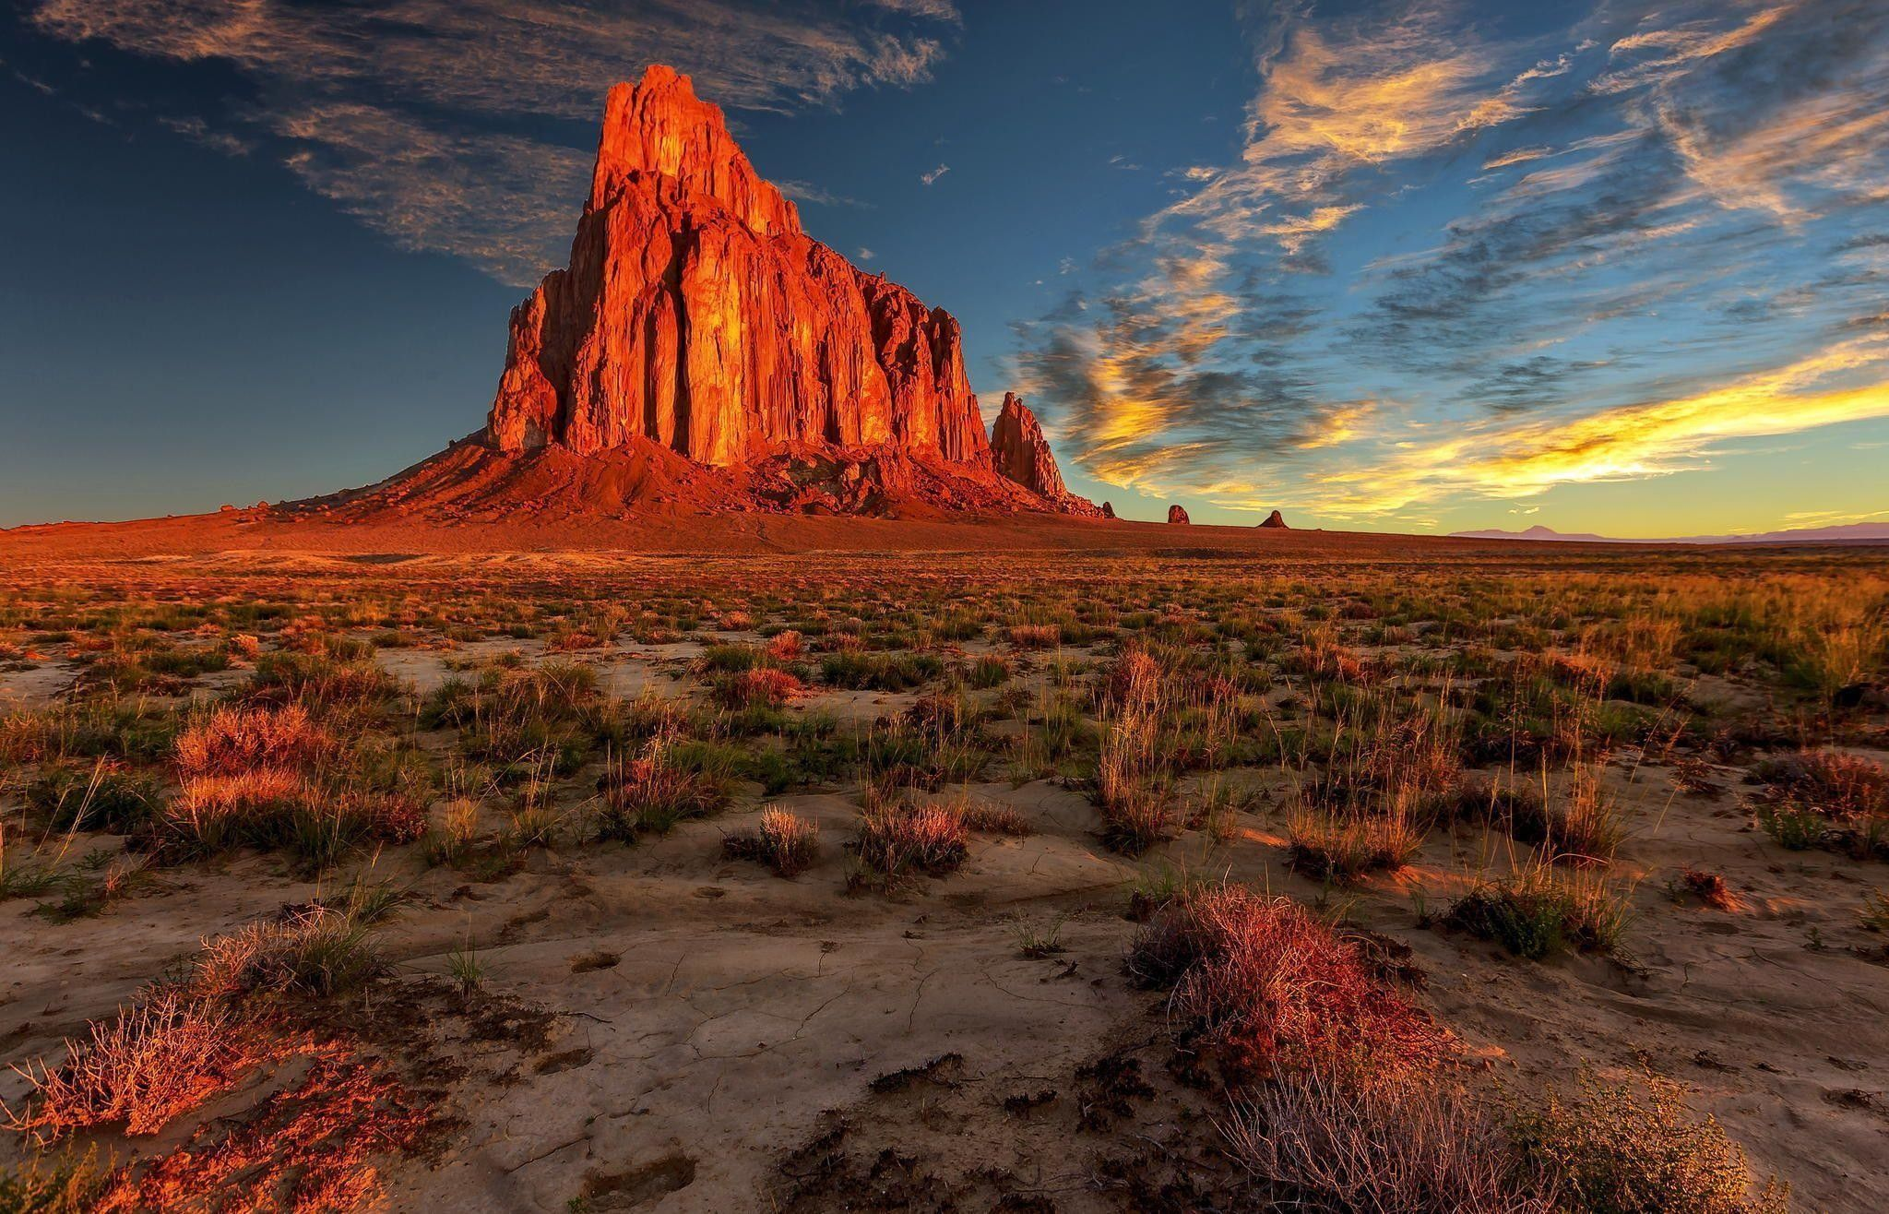
Monday, 4/26 – morning visit to Aztec Ruins NM; day hikes into Bisti Badlands
(https://www.blm.gov/visit/bisti-de-na-zin-wilderness ); night in Farmington
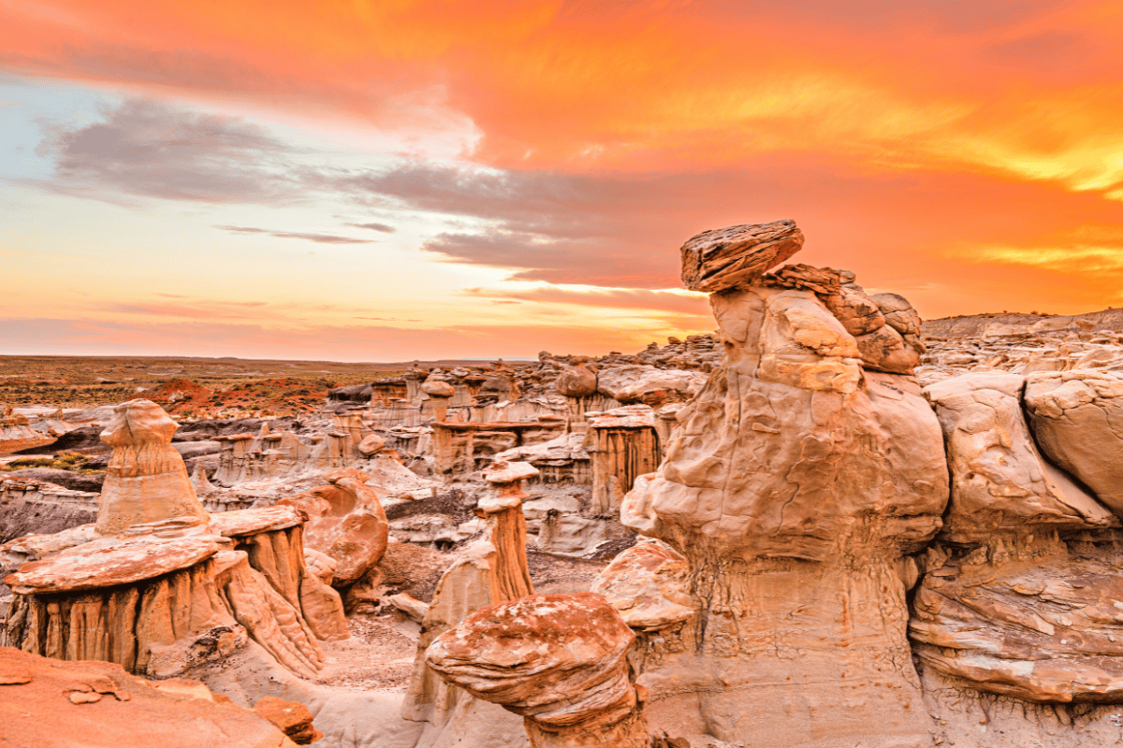

Tuesday, 4/27 – day of hiking and touring in Chaco Culture NHP; Grants for the night
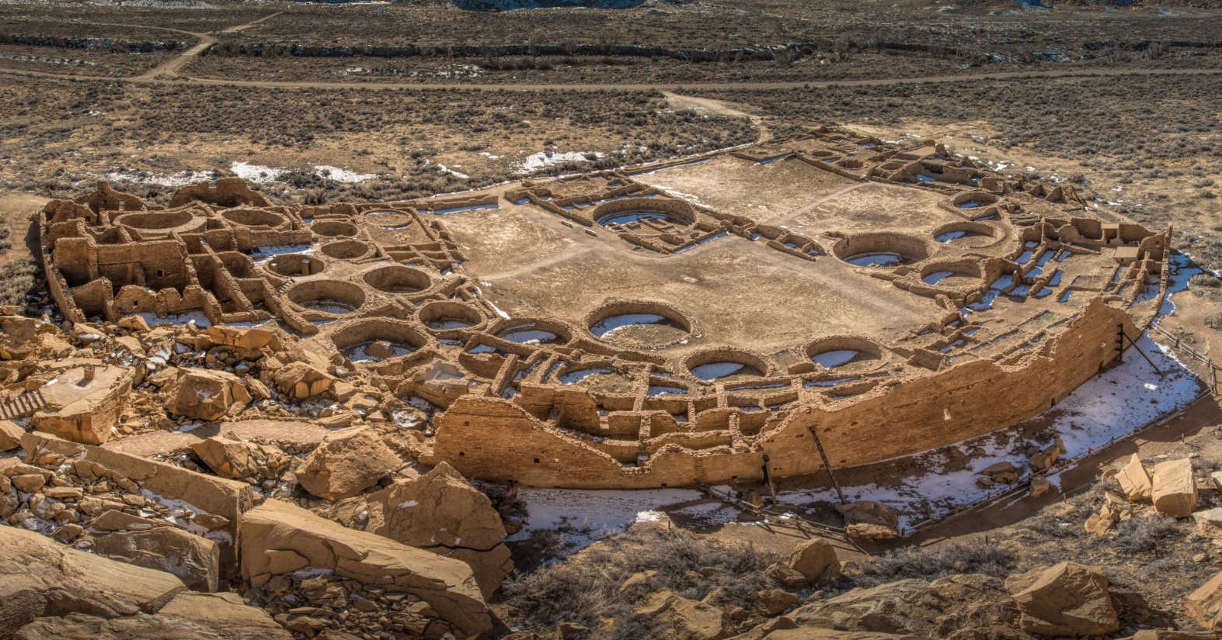

Wednesday, 4/28 – hikes into lava tubes in El Malpais NM; Albuquerque for the night
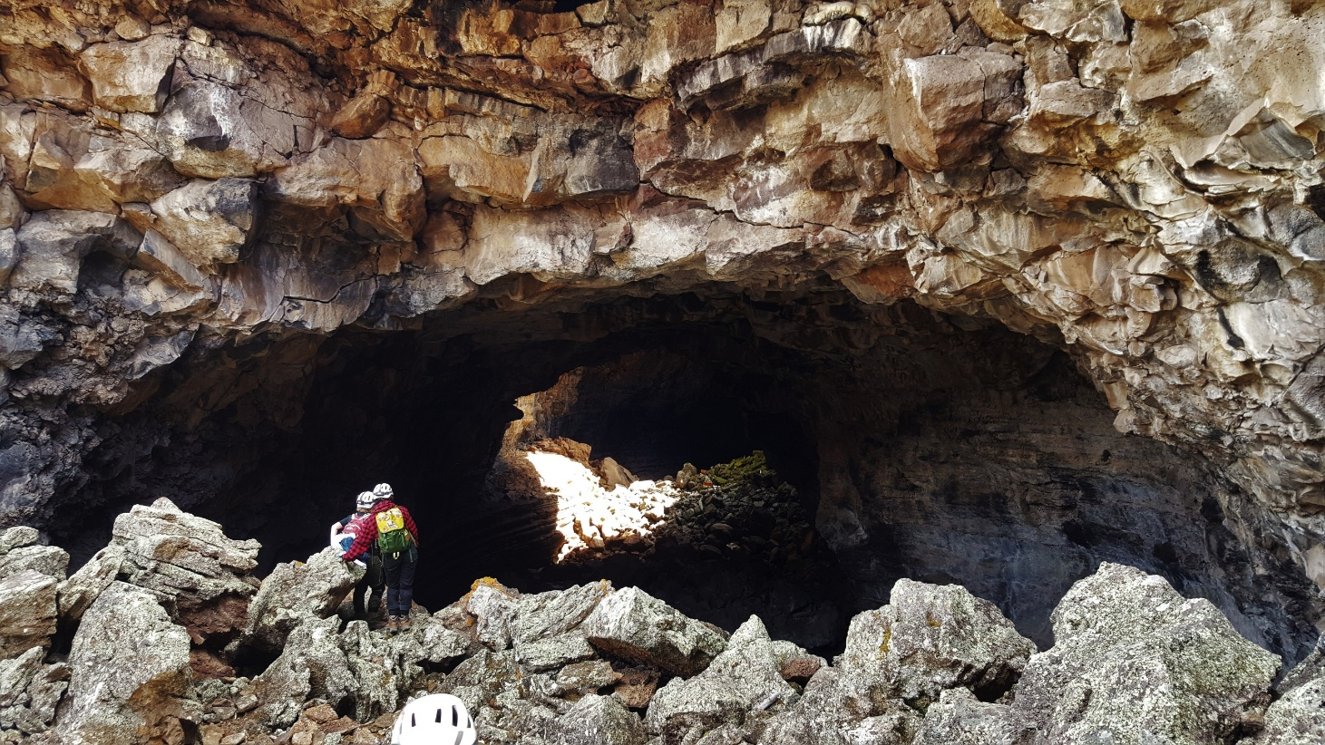
Thursday, 4/29 – Flights home (option to take red-eye flight Wednesday evening)

What’s included:
- Daily “Best View Adventures” guide service
- Lodging (double-occupancy), 7 nights
- Transportation throughout
- Entrance fees to 2 National Parks and 6 National Monuments
- Meals: 6 breakfasts, 6 lunches, 1 dinner
- Snacks and drinks aboard vehicles

Total Trip Cost = $1995 per person
(Pick-up and drop off spot = Albuquerque, NM)

