Best View Adventures:
Acadia National Park, September 2026

Sat. 9/19 – arrive in Portland, ME; drive to Bar Harbor; visitor center orientation; explore Bar Harbor
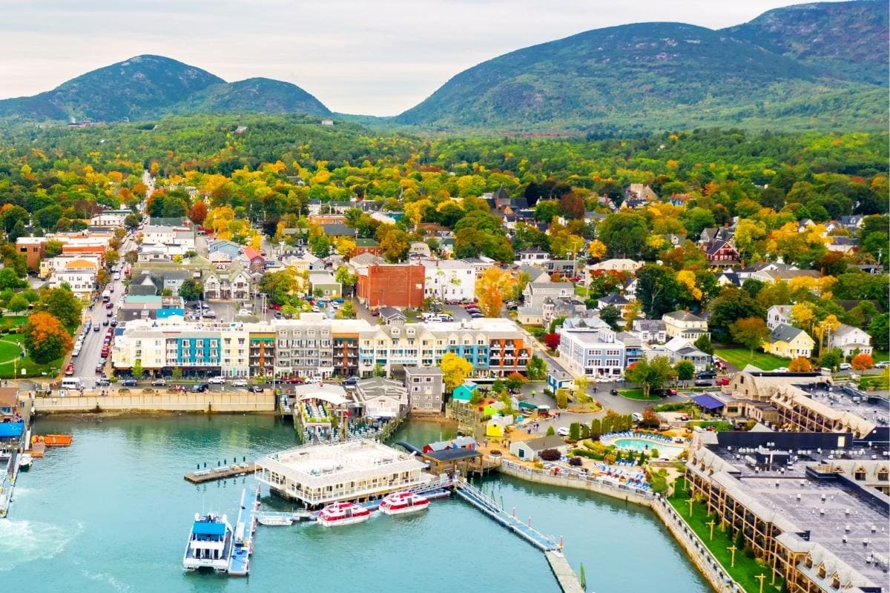
Sun. 9/20 – morning hike up Champlain Mt.; drive Park Loop Road; Jordan Pond Loop Trail hike; afternoon tea at Jordan House; horse carriage ride to Day Mt.
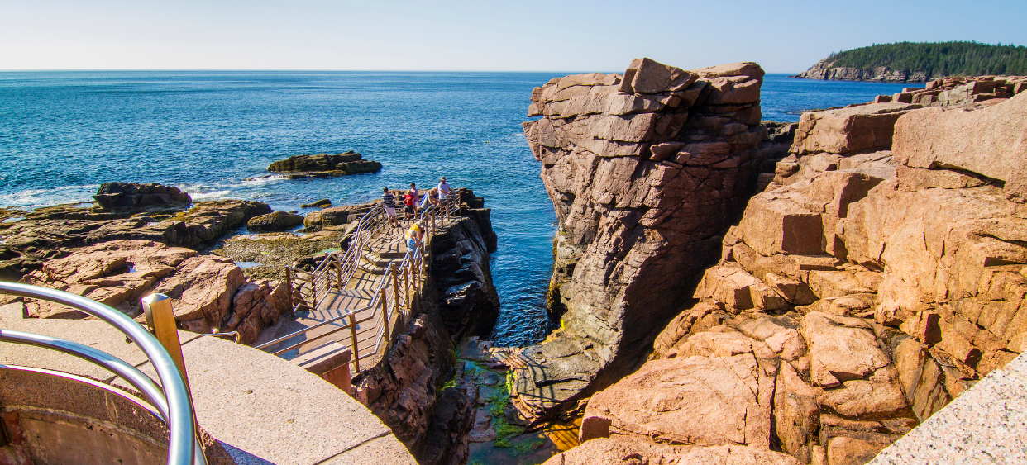
Mon. 9/21 – Sunrise atop Cadillac Mt.; morning Ebike tour of Carriage Road; afternoon and sunset at Schoodic Point section of Park

Tues. 9/22 – morning hike up Bee Hive trail; drive to Southwest Harbor for afternoon sea kayak tour;
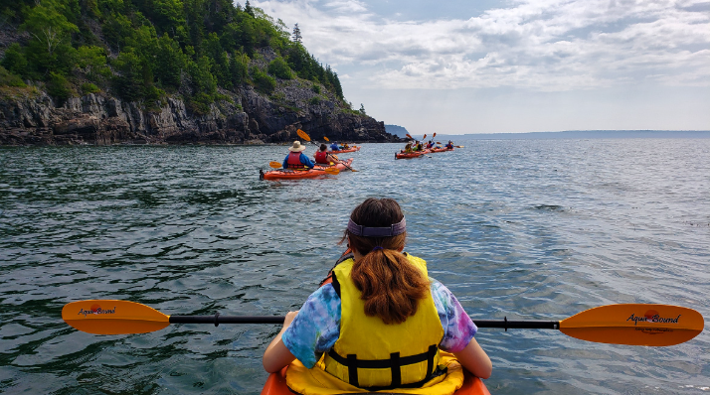
Sunset at Bass Harbor Light; lobster rolls dinner
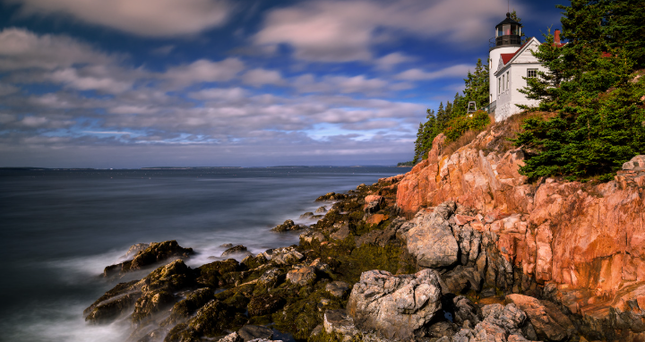

What’s included:

- Transportation from Portland, ME and throughout the trip
- 4 days’ breakfasts and lunches; one dinner
- Activities: Ebikes, sea kayaking, horse carriage tour
- Lodging in downtown Bar Harbor

Cost per person: $1995
(limit of 8 clients)

