August 2027 - Best View Adventures – Colorado

Thursday 8/19 – fly into Denver, CO for meet-up; visit Boulder on way to Estes Park
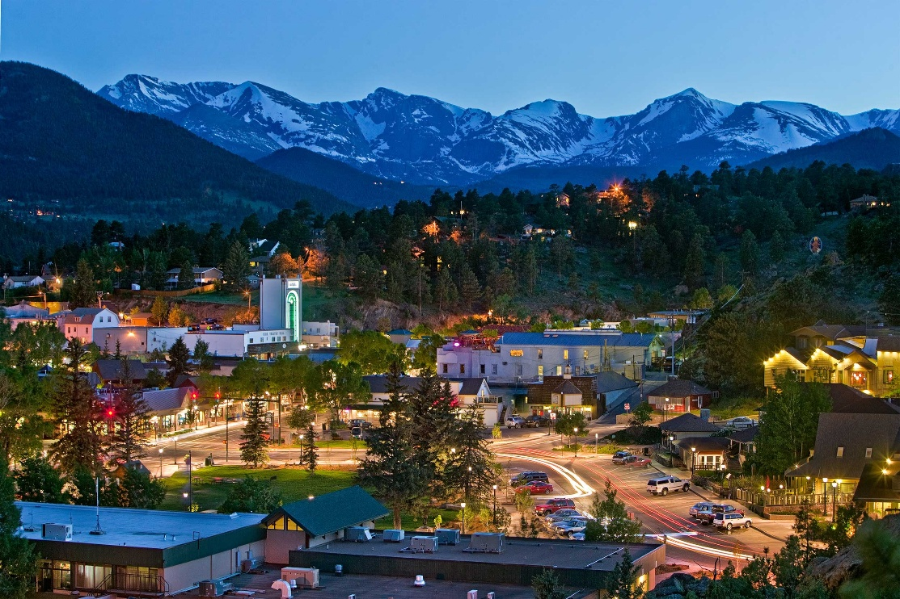

Friday 8/20 – “Low altitude” hikes in Rocky Mountains National Park – Bear Lake, Alberta Falls; Estes Park for night
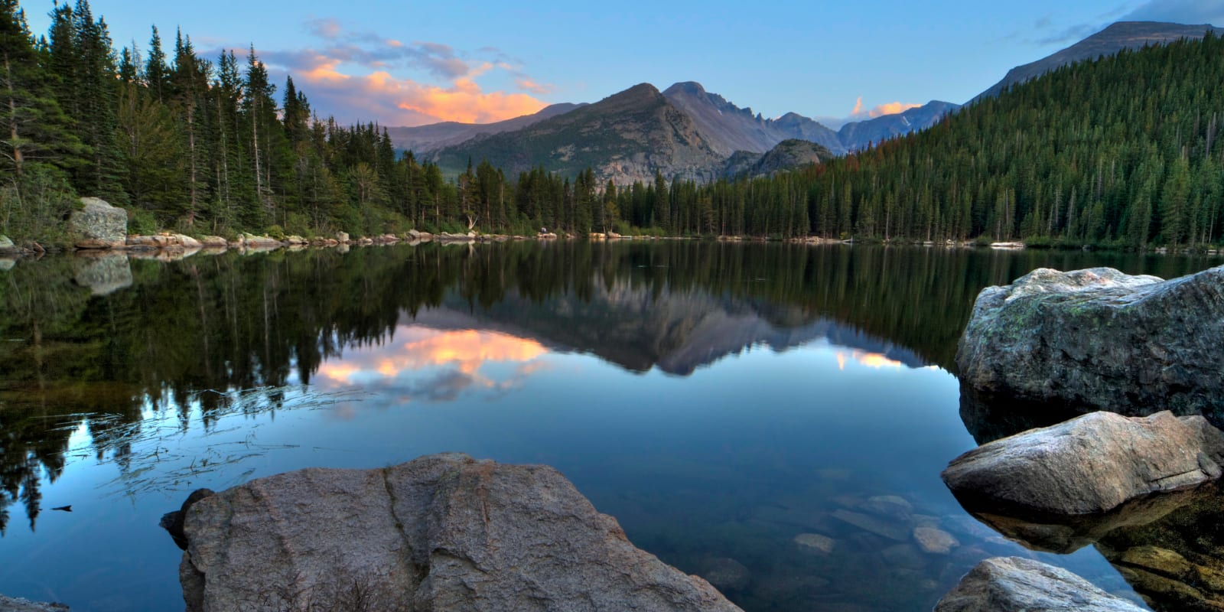

Saturday 8/21 – Traverse of Rocky Mt NP via Trail Ridge Road; alpine meadows hike; Drive to Breckenridge for dinner; Buena Vista for the night
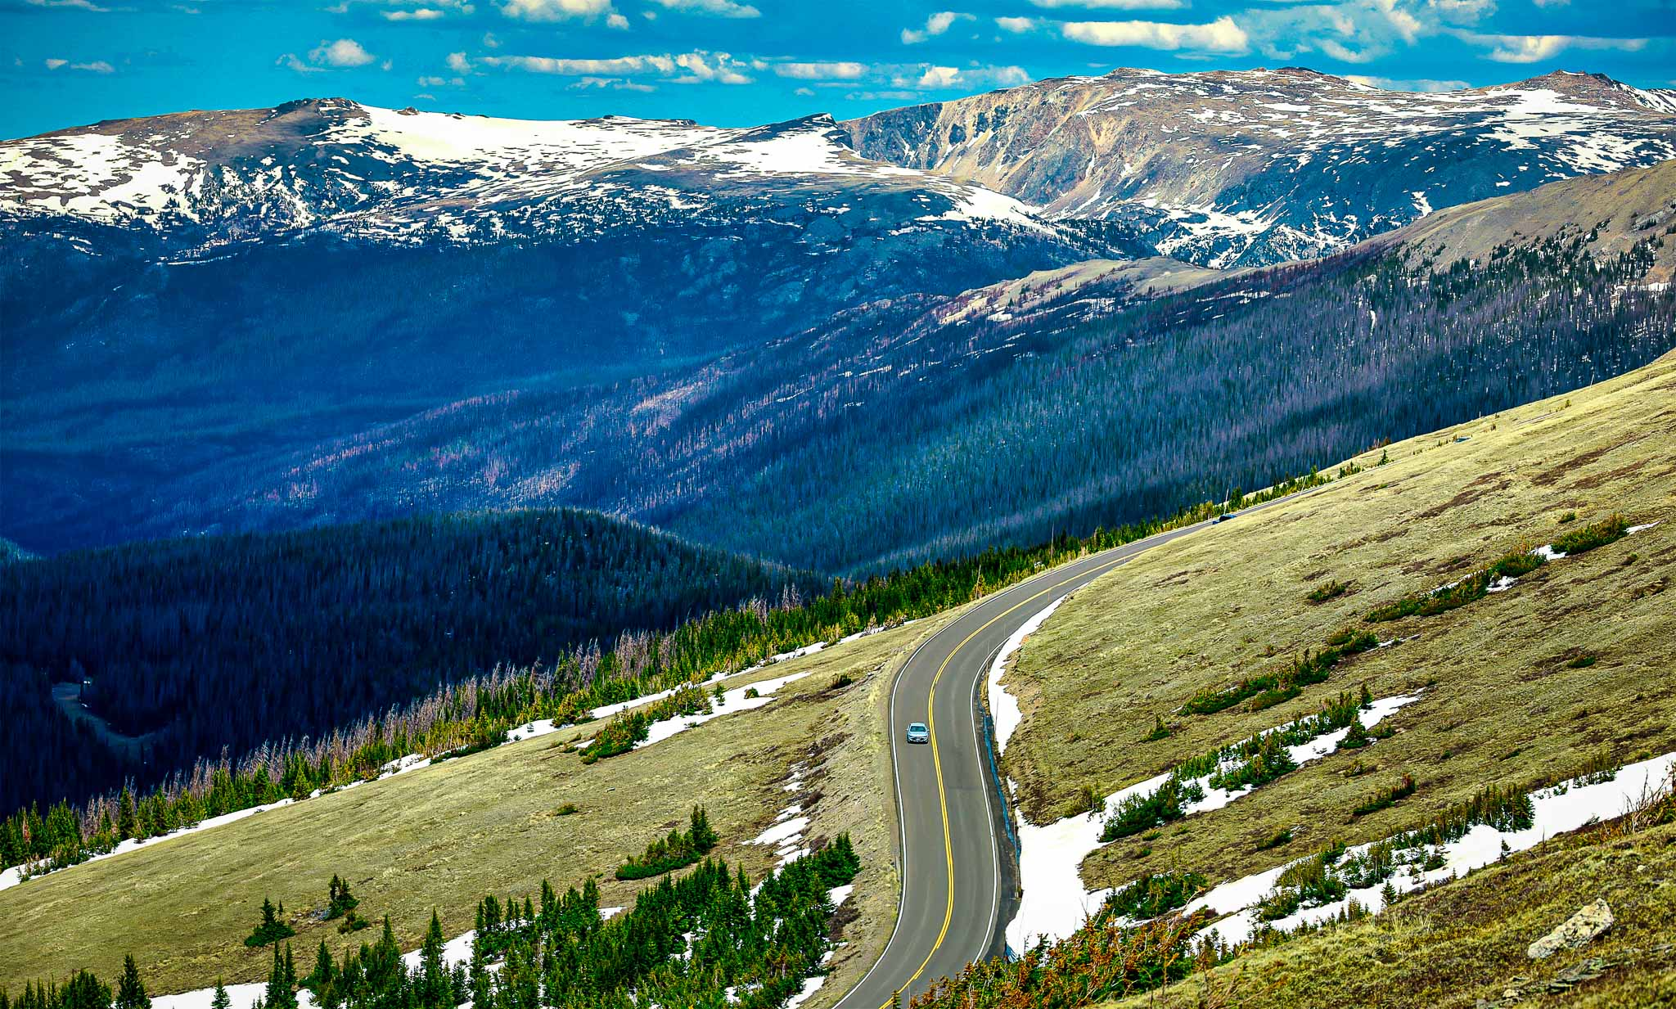

Sunday 8/22 – Day in Great Sand Dunes NP; night in Alamosa, CO
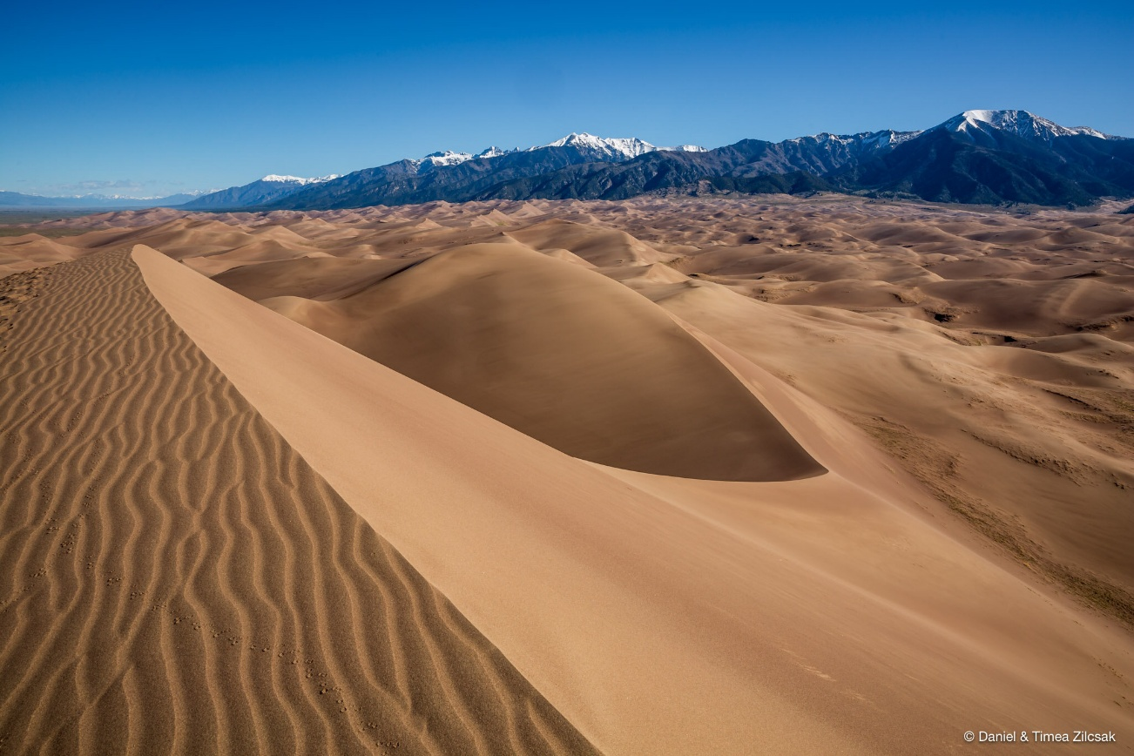

Monday 8/23 – 2nd day in Great Sand Dunes; drive to Pueblo, CO for night
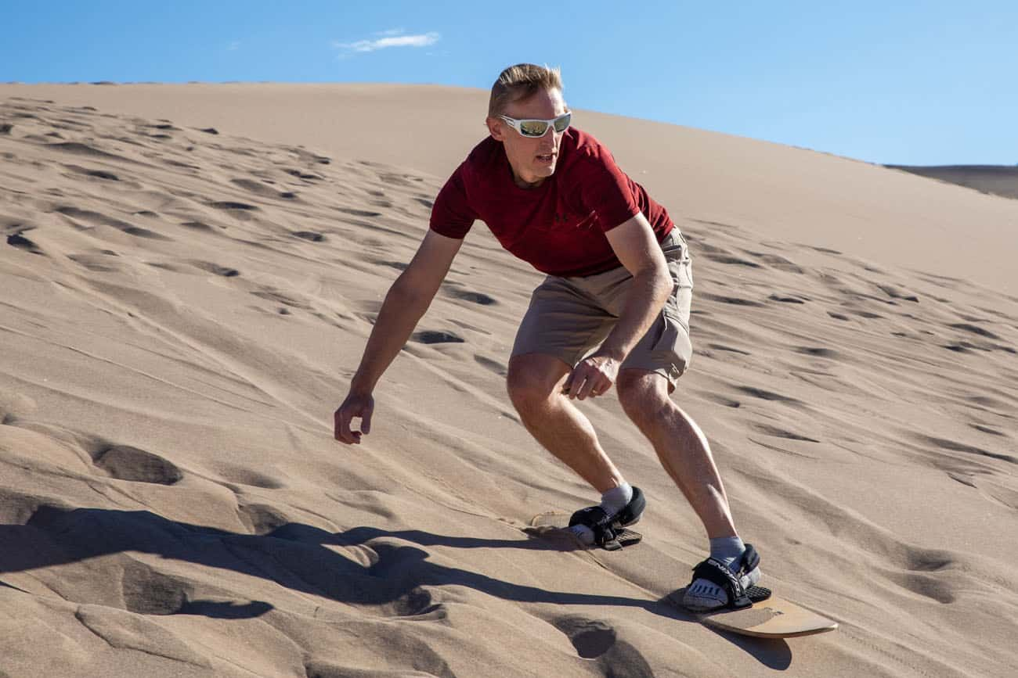

Tuesday 8/24 – Colorado Springs: Pike’s Peak, US Olympic Training Center; evening concert at Red Rocks (performer TBA); Morrison for the night
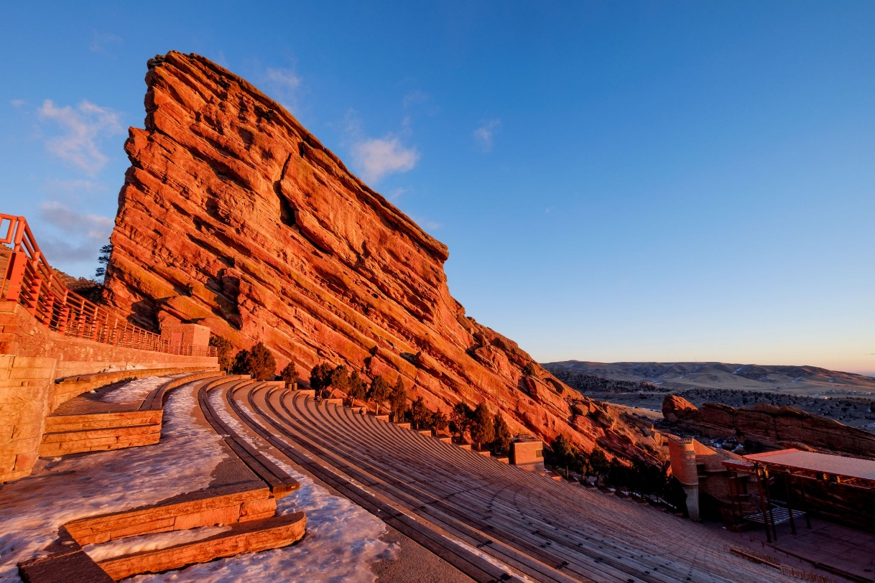

What’s included:

- Daily “Best View Adventures” guide service
- Lodging (double occupancy), 6 nights
- Transportation throughout
- Entrance fees to 2 National Parks
- Meals: 5 breakfasts, 5 lunches, 1 dinner
- Snacks and drinks aboard vehicles
Total Trip Cost = (TBA) per person

(Pick-up and drop off spot = Denver, CO airport)

