June, 2026 - Best View Adventures – Moab, Utah

Sat. 6/13 – fly into Grand Junction, CO for afternoon meet-up; drive to Dead Horse Point State Park (Utah) for sunset; night in Moab
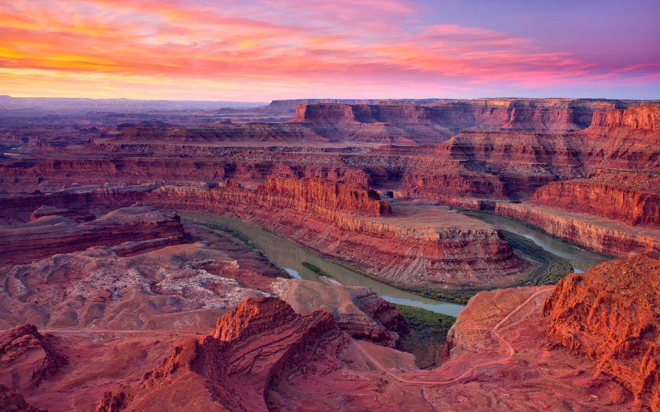

Sun. 6/14 – morning hikes in Arches National Park (Devil’s Garden); Park Ave hike and lunch; afternoon shopping, dinner, and night in Moab
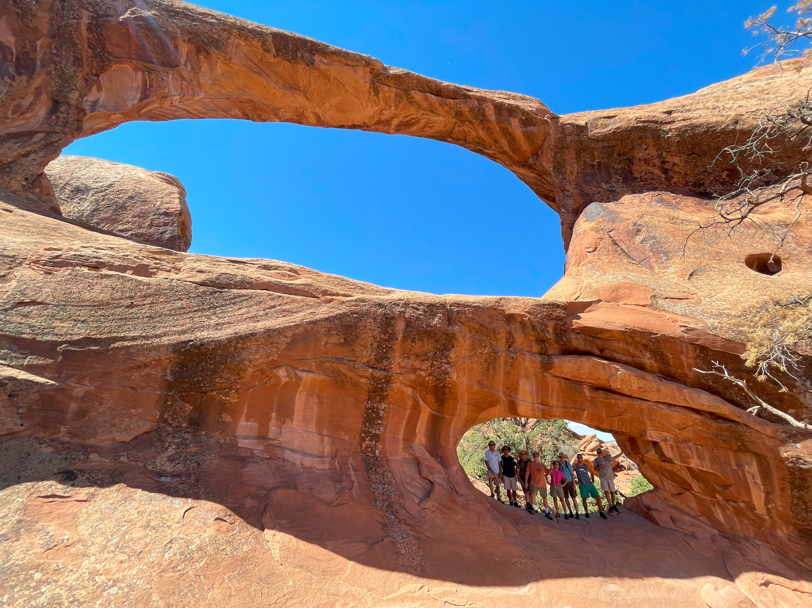
Mon. 6/15 – Morning in Canyonlands National Park; tour Island in the Sky section; afternoon hike to Delicate Arch in Arches NP; night in Moab
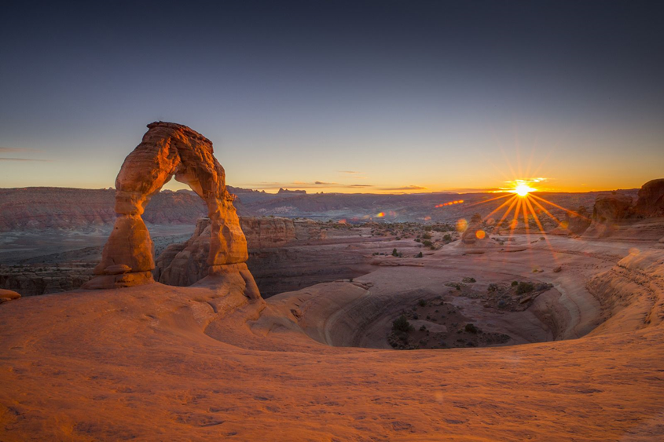

Tues. 6/16 – Clients’ choice of high-adrenaline activity options:
Whitewater Rafting - https://www.moabadventurecenter.com/westwater-canyon-rafting
Canyoneering - https://deserthighlights.com/tour/zig-zag-canyon/#tab01
Rock Climbing - https://deserthighlights.com/tour/looking-glass-arch/
Mountain Biking - https://moabcyclery.com/day-tours/ (whatever level you choose)
Drive over to Green River, UT for the night.

Wed. 6/17 – half-day hike in Irish Canyons (https://deserthighlights.com/tour/irish-canyons/ ); afternoon hike in Goblin Valley State Park
( https://duckduckgo.com/?q=images+of+goblin+valley+state+park&atb=v314-6&iax=images&ia=images ); night in Torrey

Thurs. 6/18 – tour Capitol Reef National Park; hike to Cassidy Arch; Green River for the night
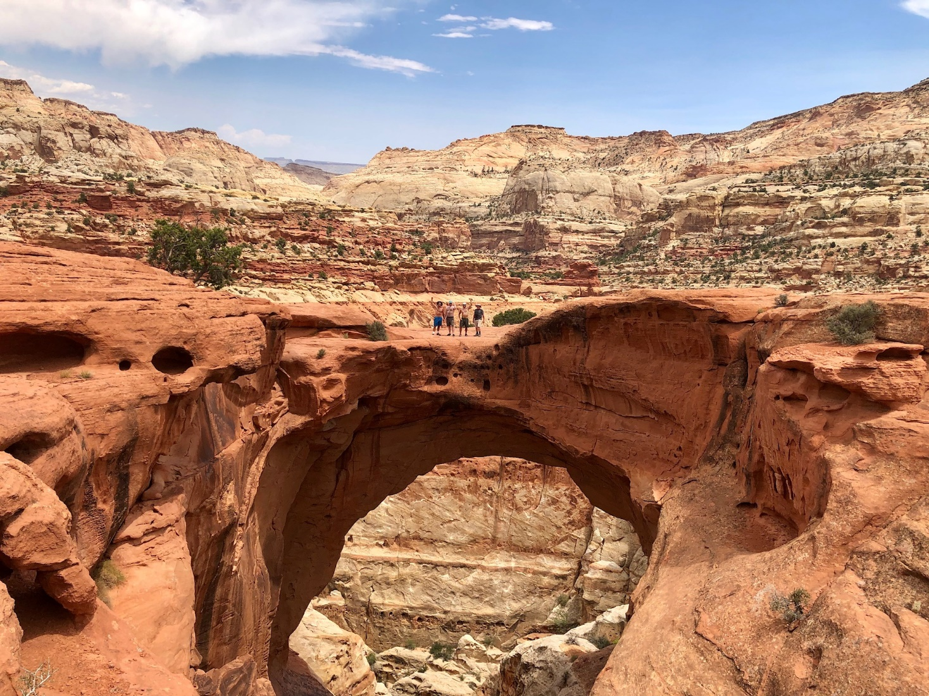
Fri. 6/19 – Morning hike to Fisher Towers; afternoon tour of Colorado National Monument; Celebratory dinner at Rockslide Brewery in Grand Junction
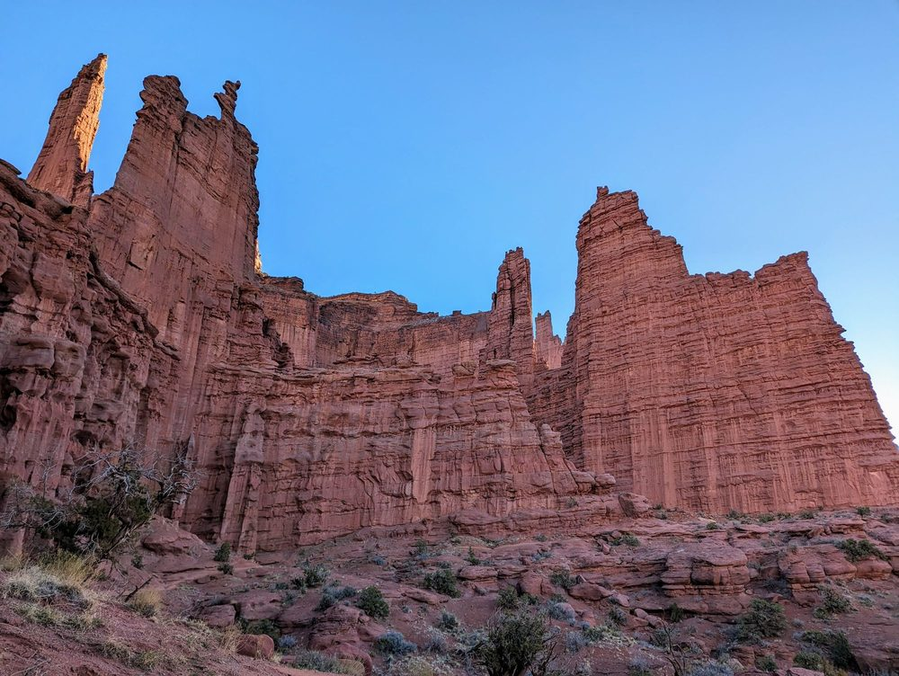
Sat. 6/20 – Flights home.
What’s included:

- Daily “Best View Adventures” guide service
- Lodging (double-occupancy), 7 nights
- Transportation throughout
- Entrance fees to 3 National Parks, 2 State Parks, and 1 National Monument
- “Client’s Choice” of Tuesday activities
- Irish Canyons guided tour
- Meals: 6 breakfasts, 6 lunches, 2 dinners
- Snacks and drinks aboard vehicles
Total Trip Cost = $2895 per person

(Pick-up and drop off spot = Grand Junction, CO airport)

