**September 2025 Best View Adventure trip :**

**Yellowstone NP**

Sat. 9/13 : meet at Bozeman, MT airport; drive to West Yellowstone

Sun. 9/14 : **Yellowstone NP** ; morning touring of Lower and Midway Geyser Basins boardwalks ; afternoon at Old Faithful Village

Mon. 9/15 – hiking the rim trail along the Grand Canyon of the Yellowstone; Inspiration Point

Tues. 9/16 : West Thumb Geyser Basin; Yellowstone Lake, Grant Village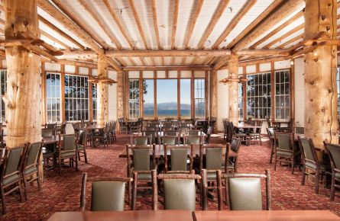

Wed. 9/17 : Day trip into Grand Tetons National Park; boat ride across Jenny Lake to hike in Cascade Canyon

**Thurs. 9/18** : Tower Junction; Mt. Washburn climb or hike into Lamar Valley

Fri. 9/19 – Norris Geyser Basins; Mammoth Hot Springs

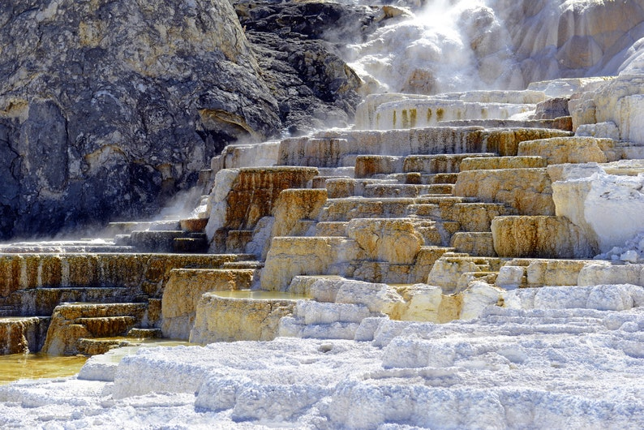

Sat. 9/20 – flights home from Bozeman, MT

**Trip Details** - **What is included**:

* Transportation throughout
* Personal Guided hikes
* Park entrance fees
* Lodging for 7 nights
* Breakfasts and lunches all 6 days, 5 dinners
* Snacks, soft drinks, gorp, power bars, etc. in vans

**Total Cost** : $2795 per person (limit of 8 clients)