**May 2025 Best View Adventure trip :**

**Black Hills of South Dakota**

Tues. 5/13 : meet at Rapid City airport; visit to Sturgis; night in RC

Wed. 5/14 : multiple hikes in Badlands NP; Wall Drug; RC for night

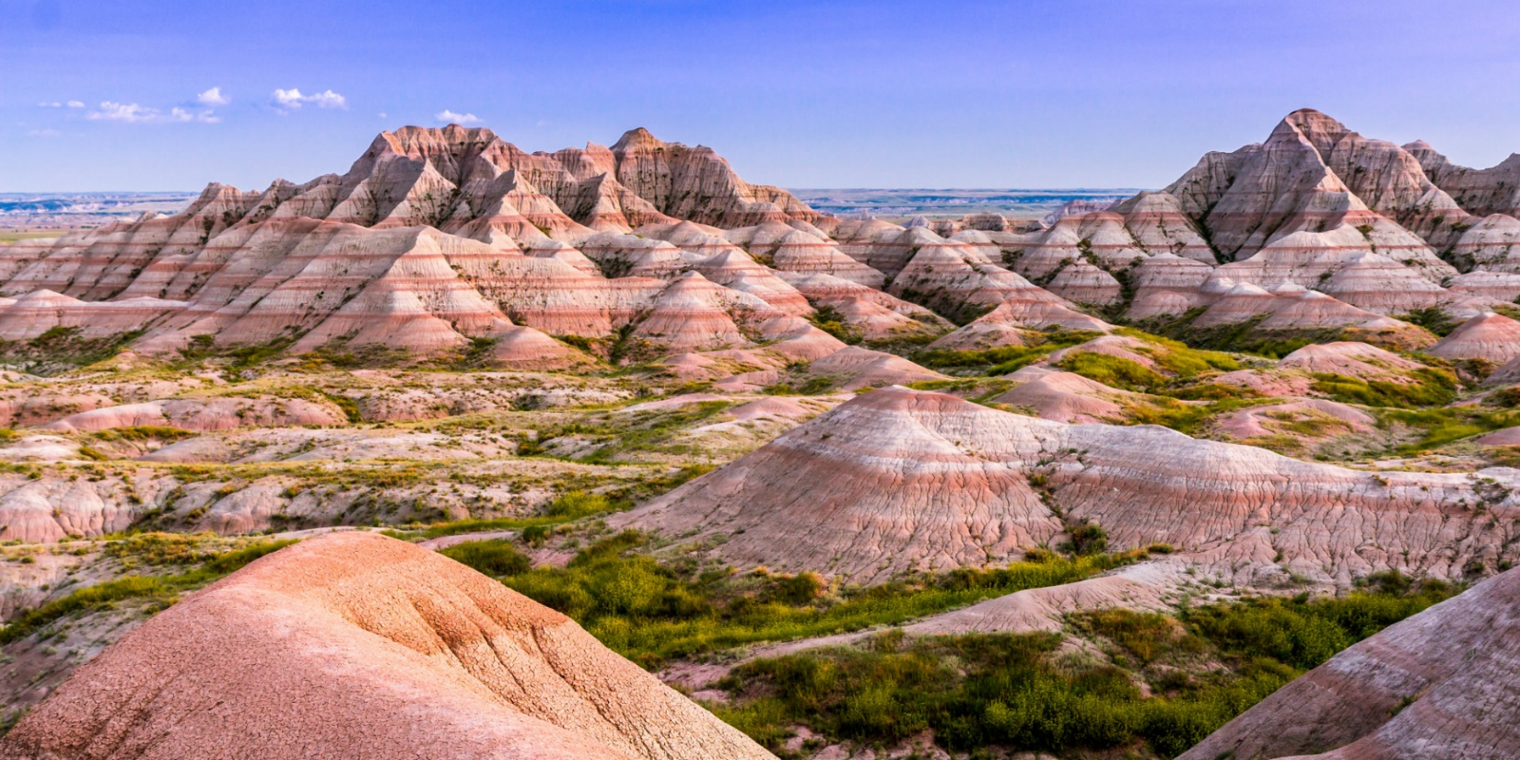

Thurs. 5/15 : day trip to Devil’s Tower NM; Spearfish Canyon drive; Deadwood; Rapid City for night

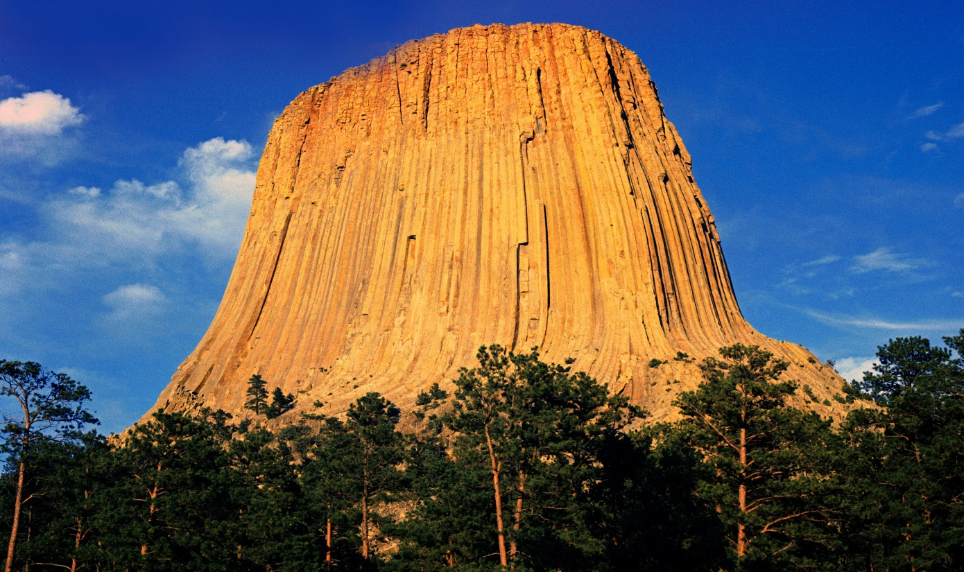

Fri. 5/16 : Mount Rushmore NM; Crazy Horse monument; afternoon hike in Custer state park; night in Custer

Sat. 5/17 : Wind Cave NP; Jewel Cave NM; back to Rapid City

Sun. 5/18 : flights home

**Trip Details**

**What is included**:

* Transportation throughout
* Park entrance fees
* Lodging for 5 nights
* Breakfasts and lunches all 5 days, 1 dinner
* Snacks, soft drinks, gorp, power bars, etc. in vans

**Total Cost** : $1795 per person (limit of 6 clients)